**DEFENCE SERVICES ACADEMY**

**DEPARTMENT OF COMPUTER SCIENCE**

**IMPLEMENTATION OF AN AUTOMATED DYNAMIC WEAPON RANGE VISUALIZATION AND ENGAGAEMENT PLANNING FOR MILITARY TACTICAL SUPPORT SYSTEM USING GEOSPATIAL DATA**

**BY**

**AUNG NYI NYI MIN**

**M.C.Sc Thesis**

**MARCH, 2025**

**PYIN OO LWIN**

**DEFENCE SERVICES ACADEMY**

**DEPARTMENT OF COMPUTER SCIENCE**

**IMPLEMENTATION OF AN AUTOMATED DYNAMIC WEAPON RANGE VISUALIZATION AND ENGAGAEMENT PLANNING FOR MILITARY TACTICAL SUPPORT SYSTEM USING GEOSPATIAL DATA**

By

Captain AUNG NYI NYI MIN

A THESIS

SUBMITTED TO THE DEFENCE SERVICES ACADEMY

IN FULFILMENT OF THE REQUIREMENTS

FOR THE DEGREE OF

MASTER OF COMPUTER SCIENCE

(M.C.Sc)

MARCH, 2025

PYIN OO LWIN

**DEFENCE SERVICES ACADEMY**

This is to certify that we have examined, and recommend to the supervision committee for the M.C.Sc Program for acceptance the thesis entitled **“IMPLEMENTATION OF AN AUTOMATED DYNAMIC WEAPON RANGE VISUALIZATION AND ENGAGAEMENT PLANNING FOR MILITARY TACTICAL SUPPORT SYSTEM USING GEOSPATIAL DATA ”**, submitted by**Captain Aung Nyi Nyi Min,** Roll No**. CS-10 (March, 2025)** in fulfillment of the requirements for the degree of Master of Computer Science.

**Board of Examiners:**

1. Lt.Col.Phone Naing

Professor

Department of Computer Science ---------------------------Defence Services Academy (Chairman)

1. Major Hein Naing

Assistant Lecturer

Department of Computer Science ---------------------------Defence Services Academy (Supervisor)

1. Major Aung Myo Thu

Assistant Lecturer

Department of Computer Science ---------------------------Defence Services Academy (Member)

1. Major Yar Zar Doe

Assistant Lecturer

Department of Computer Science ---------------------------Defence Services Academy (Member)

1. Dr. Nyo Nyo Yee

Professor/ Head

Department of Information Science --------------------------

University of Technology (External Examiner)

(Yatanarpon Cyber City)

**DEFENCE SERVICES ACADEMY**

**DEPARTMENT OF COMPUTER SCIENCE**

**IMPLEMENTATION OF AN AUTOMATED DYNAMIC WEAPON RANGE VISUALIZATION AND ENGAGAEMENT PLANNING FOR MILITARY TACTICAL SUPPORT SYSTEM USING GEOSPATIAL DATA**

**BY**

**AUNG NYI NYI MIN**

**Approved By**

|  |  |
| --- | --- |
| **Supervisor** | **Co-Supervisor** |
| **Lieutenant Colonel Zar Nay Lin** | **Major Yar Zar Doe** |
| **Ph.D. (Computer Science)** | **Ph.D. (Computer Science)** |
| **Lecturer** | **Assistant Lecturer** |
| **Department of Computer Science** | **Department of Computer Science** |

**March, 2025**

# ACKNOWLEDGEMENTS

I would like to express my profound gratitude to **Major General Soe Myat Htut**, Commandant of Defence Services Academy for allowing me to attend the Master of Computer Science, program at Defence Services Academy.

I would special thanks to Rector of Defence Services Academy, **Brigadier General Thein Lwin**, for his kind permission and encouragement for my Master Degree in Computer Science.

I wish to extend my thanks to person, **Lieutenant Colonel Soe Win Myint**, Head of Department of Computer Science at Defence Services Academy, for his close support in doing thesis work, attending seminars, giving valuable advices and guidance for preparation of this thesis.

I am highly indebted to **Lieutenant Colonel Zar Nay Lin,** who is responsible for Master of Computer Science at Defence Services Academy, for his immense patience and providing an incredible amount of guidance.

I must particularly express my thankfulness to my coaches, **Lieutenant Colonel Zar Nay Lin**, Lecturer and supervisor, Department of Computer Science at Defence Services Academy, for valuable advices, their close supervision, kind guidance and support and cooperation of master degree program, and I realized the valuable suggestions, understanding and generous encouragements during a long period of study for thesis paper.

Last but not least, many thanks to all persons who directly and indirectly contributed toward the completion of this thesis.

# ABSTRACT

The effective planning and execution of military operations depend on precise situational awareness and robust decision support systems. This research presents the design and implementation of a military tactical support system that leverages advanced geospatial data integration and computational techniques. By addressing critical challenges such as real-time range assessment, terrain analysis, and engagement strategy optimization, the system enhances operational readiness and precision in mission-critical scenarios.

The proposed system dynamically models weapon engagement zones using geospatial data, incorporating factors such as obstacles and weapon-specific performance parameters. By integrating Geographic Information System (GIS) frameworks and advanced spatial analysis algorithms, the system enables real-time visualization of weapon ranges, highlighting viable target zones and blind spots. Additionally, optimization techniques, including genetic algorithms and graph-based pathfinding, support strategic planning by recommending optimal engagement strategies that minimize collateral damage, maximize coverage, and ensure operator safety.

Built on a modular architecture, the system features a robust data ingestion pipeline for geospatial datasets, a real-time analytics engine, and an interactive user interface designed for usability in field conditions. This research advances geospatially-driven tactical decision-making by providing an automated solution that bridges theoretical geospatial analytics with real-world military applications. The methodologies and insights presented have the potential to revolutionize engagement planning, enhancing the precision and efficacy of military missions.

**Keywords:** Automated Visualization, Defense Technology, Engagement Planning, Geospatial Data, Weapon Range Modeling

# TABLE OF CONTENTS

**Page**

ACKNOWLEDGEMENTS i

ABSTRACT ii

TABLE OF CONTENTS iii

LIST OF ABBREVIATIONS vii

LIST OF FIGURES viii

LIST OF EQUATIONS ix

LIST OF TABLES x

**CHAPTER TITLE**

1 INTRODUCTION 1

1.1 Problem Statement 2

1.2 Motivation 3

1.3 Aim of Thesis 4

1.4 Objective of Thesis 5

1.5 Overview of the System 5

1.6 Organization of Thesis 6

2 BACKGROUND KNOWLEDGE 7

2.1 The Evolution of Military Geospatial Intelligence and Weapon

Range Visualization 7

2.2 Flutter for Android Application 9

2.3 Geographic information system (GIS) 10

2.3.1 GIS for Military Applications 11

2.3.2 GIS Data Models and Techniques 12

2.3.3 GIS and Real-Time Data Integration 12

2.4 Map Caching for Online and Offline Use 13

Table of Contents (continued)

2.4.1 Purpose of Map Caching 14

2.4.2 Types of Map Caching 14

2.4.3 Implementation of Map Caching 15

2.4.4 Online and Offline Use Cases 16

2.5 MBTiles Format for UTM Display 16

2.5.1 Understanding MBTiles Specification 17

2.5.2 Tile Coordinate System 17

2.5.3 Format Specifications 18

2.6 Military Grid Reference System (MGRS) 18

2.6.1 Structure of MGRS Coordinates 19

2.6.2 Advantages of MGRS for Military Applications 20

2.6.3 Applications of MGRS in Military Operations 21

2.7 LatLang (Latitude, Longitude) to MGRS Conversion 22

2.7.1 The Need for LatLon to MGRS Conversion 22

2.7.2 Conversion Process 23

2.7.3 Conversion from Latitude/Longitude to MGRS 24

2.8 Tactical Decision Support System (TDSS) 25

2.8.1 Key Components of TDSS 26

2.8.2 Applications of TDSS in Military Operations 26

2.8.3 Advantages of TDSS 27

2.9 Distance Calculation from One Place to Another 28

2.10 Bearing Calculation on a Map from One Place to Another 28

2.10.1 Convert to Degrees 29

2.10.2 Convert to Mils 30

2.11 Finding Suitable Weapons for a Single Target Using Euclidean

Distance 30

2.12 Weighted Scoring System in The Most Suitable Weapon Selection 31

2.13 Pathfinding with A* (A-Star) Algorithm and Barrier Avoidance 32

Table of Contents (continued)

2.13.1 The A* (A-Star) Algorithm 33

2.13.2 Barrier Avoidance in A* 33

2.13.3 Heuristic Functions for A* Search Algorithm in Pathfinding 34

2.14 Lanchester’s Square Law for decision making Feedback 35

2.14.1 Overview of Lanchester’s Square Law 35

2.14.2 Applications in Tactical Decision-Making Using Lanchester’s

Law 37

2.15 Literature Review 37

2.16 Summary 42

3 SYSTEM DESIGN AND IMPLEMENTATION 43

3.1 Proposed System Architecture of Android Application 43

3.2 Overall Design of the System 44

3.3 Detail Design for Admin 45

3.4 Detail Design for User 46

3.5 Proposed System Design for Database 47

3.6 Example: Distance Calculation from Pyin Oo Lwin to Mandalay 48

3.7 Example: Bearing Calculation from Pyin Oo Lwin to Mandalay 49

3.8 Example: Latitude/ Longitude Coordinate to MGRS Conversion 51

3.9 Example Calculation for Selection The Most Suitable Weapon 53

3.10 Example Calculation: Battle Results for TDSS Feedback 54

3.10.1 Step 1: Calculate Force Strength 55

3.10.2 Step 2: Calculate Combat Potential 56

3.10.3 Step 3: Calculate Alpha and Beta Coefficients 56

3.10.4 Step 4: Calculate Battle Duration 56

3.10.5 Step 5: Calculate Remaining Forces 57

3.10.6 Step 6: Summary of Battle Results 57

3.10.7 Step 7: Most Dangerous Enemy Calculation 58

3.11 Implementation 59

Table of Contents (continued)

3.12 Summary 64

4 CONCLUSION 65

4.1 Advantages of the System 66

4.2 Disadvantages of the System 66

4.3 Further Extensions 67

REFERENCES 69

APPENDIX/APPENDICES 72

# LIST OF ABBREVIATIONS

ADWRVEPS Automated Dynamic Weapon Range Visualization and Engagement Planning System

AHP Analytic Hierarchy Process

GIS Geographic Information System

GPS Global Positioning System

MGRS Military Grid Reference System

NATO North Atlantic Treaty Organization

TDSS Tactical Decision Support System

UTM Universal Transverse Mercator

# LIST OF FIGURES

**Figure Page**

2.1A geographic information system (GIS) 11

2.2Map Caching with Tiles 14

2.3Implementation of Map Caching 15

2.4MBTiles Format display map with each zoom level 16

2.5MGRS Grid Zone 19

2.6Components of MGRS 20

2.7Tactical Decision-Making Process 25 2.8 Bearing Calculation on a Map from One Place to Another 29

3.1Overall System Design for Military Tactical Support System 42

3.2Detail Design of the System 43

3.3 Flow Chart for Admin 44

3.4Flow Chart for User 45

3.5Database Design of The System 46

3.6Map Integration for User and Admin with UTM Map 59

3.7Map Integration for User and Admin with Google Hybrid Map 60

3.8Search Locations by MGRS Format 60

3.9Calculate Distance, Bearing and Suitable Weapon for Set

Target Two Points and for Current Location to Center Point 61

3.10Give Feedbacks for Most Suitable Weapon 61

3.11 Draw Firing range for motor guns on map 62

3.12Add My Weapon Data to System 62

3.13Drawing Routes Avoiding the Obstacles On map 63

3.14 Display TDSS Feedbacks 63

# LIST OF EQUATIONS

**Equation Page**

2.1 **Determine UTM Zone** 24

2.2Project to UTM Easting 24

2.3Project to UTM Northing 24

2.4Haversine of Central Angle (a) 28

2.5Central Angle (c) 28

2.6Great-Circle Distance (d) 28

2.7Difference in Longitude 29

2.8Initial Bearing Angle (θ) in Radians 29

2.9Initial Bearing in Degrees 29

2.10Initial Bearing in Mils 30

2.11Euclidean Distance Between Two Points 31

2.12Weapon Effectiveness Score 32

2.13A* (A-Star) Algorithm 33

2.14Manhattan Distance 34

2.15Diagonal Distance 34

2.16Mutual Attrition Model using Lanchester’s Law 35

# LIST OF TABLES

**Table Page**

3.1All suitable Weapon Data 53

3.2Summary of battle results 57

# CHAPTER 1

# INTRODUCTION

In modern military operations, the need for precise and effective tactical decision-making has become more critical than ever. As technological advancements reshape the battlefield, traditional methods of engagement planning and weapon range visualization are proving insufficient to address the complexities of contemporary conflicts. The integration of geospatial data and automated decision-support systems offers an unprecedented opportunity to enhance situational awareness, optimize engagement strategies, and improve operational outcomes.

Military operations often occur in dynamic and unpredictable environments, where factors such as terrain, weather conditions, and the performance characteristics of weapon systems must be carefully analyzed. Accurate and real-time visualization of weapon engagement ranges is crucial for identifying strategic opportunities, minimizing risks, and reducing collateral damage. However, existing approaches to engagement planning are often static, time-consuming, and reliant on manual interpretation of data, leading to potential inefficiencies and vulnerabilities.

This thesis proposes the development of an *Automated Dynamic Weapon Range Visualization and Engagement Planning System* (ADWRVEPS), designed to address these challenges by leveraging geospatial data and advanced computational techniques. The system integrates Geographic Information System (GIS) technology with real-time analytics to dynamically model and visualize weapon engagement zones, accounting for critical variables such as terrain elevation, obstacles, and atmospheric conditions. Additionally, it incorporates optimization algorithms to generate actionable engagement strategies, enabling military planners to make informed decisions with greater speed and accuracy.

The primary contributions of this research are threefold. First, it introduces a novel framework for dynamic weapon range visualization that offers a high-fidelity, interactive representation of the battlespace. Second, it develops a suite of engagement planning tools that optimize weapon deployment based on mission objectives and environmental constraints. Finally, it evaluates the system’s performance in simulated operational scenarios, demonstrating its scalability, adaptability, and potential to enhance the effectiveness of military operations.

By bridging the gap between geospatial analytics and real-world tactical decision-making, this research aims to contribute to the development of next-generation military support systems. The insights gained from this work have far-reaching implications, not only for defense applications but also for broader fields such as disaster management and homeland security, where dynamic situational awareness and precise planning are equally critical.

## 1.1 Problem Statement

Effective military operations rely on precise tactical planning, particularly when deploying weapon systems in complex and dynamic environments. The ability to visualize weapon engagement ranges and develop optimized engagement strategies is critical for ensuring mission success, minimizing collateral damage, and maximizing resource efficiency. However, existing methods for weapon range visualization and engagement planning face several significant limitations:

1. **Static and Manual Processes**: Traditional approaches to engagement planning often involve manual analysis of static maps and outdated information. These methods are time-consuming and prone to human error, reducing the agility of tactical decision-making.
2. **Lack of Real-Time Adaptability**: Modern battlefields are highly dynamic, with rapidly changing conditions such as terrain, enemy movements, and environmental factors. Existing systems fail to provide real-time updates, leading to delays in strategy adjustments.
3. **Inadequate Integration of Geospatial Data**: While geospatial data has become increasingly accessible, its integration into military decision-making tools remains underutilized. Current systems lack the capability to process and analyze complex geospatial datasets effectively, resulting in limited situational awareness.
4. **Limited Visualization Capabilities**: Current visualization tools are often simplistic, failing to provide detailed, interactive, and intuitive representations of weapon engagement zones. This hampers the ability of military personnel to quickly assess and respond to tactical opportunities.
5. **Inefficient Engagement Strategies**: The absence of automated optimization algorithms in planning systems leads to suboptimal deployment of weapon systems. This inefficiency can result in unnecessary risks, resource wastage, and missed operational objectives.

The convergence of these limitations underscores the need for an advanced solution that combines dynamic geospatial data analysis, real-time visualization, and automated engagement planning.

That seeks to address these challenges by developing an “Automated Dynamic Weapon Range Visualization and Engagement Planning System” (ADWRVEPS) that leverages geospatial data, advanced algorithms, and state-of-the-art visualization techniques to transform military tactical support and decision-making.

## 1.2 Motivation

Modern military operations are increasingly conducted in complex and dynamic environments, where success depends on the ability to make informed and timely decisions. Traditional methods of tactical planning and weapon deployment, rooted in static maps and manual calculations, are no longer sufficient to address the multifaceted challenges of contemporary battlefields. The integration of advanced geospatial analytics and real-time data processing offers a transformative opportunity to enhance situational awareness, enabling commanders to visualize the battlefield with unprecedented clarity. This motivation stems from the urgent need to bridge the gap between available technological advancements in Geographic Information Systems (GIS), computational modeling, and decision support, and their practical application in tactical military scenarios. A system that dynamically adapts to terrain, environmental factors, and weapon capabilities can eliminate operational inefficiencies, streamline resource allocation, and provide actionable insights to decision-makers.

Beyond the immediate military context, this research is motivated by the broader implications of leveraging cutting-edge technologies for precision and ethical considerations. Modern warfare emphasizes minimizing collateral damage, ensuring operational precision, and adapting rapidly to unpredictable conditions. By automating weapon range visualization and engagement planning, this work seeks to reduce human error, enhance safety, and support scalable solutions applicable across diverse scenarios such as disaster response and homeland security. The development of a robust, adaptable system not only promises to revolutionize military tactics but also contributes to the evolution of intelligent decision-making tools that are critical for addressing both current and future challenges in multidimensional operational environments.

## 1.3 Aim of Thesis

The aim of this thesis is to develop an automated system for dynamic weapon range visualization and engagement planning that leverages geospatial data and advanced computational techniques to enhance military tactical decision-making and operational efficiency.

## 1.4 Objective of Thesis

The objectives of this thesis are as follows:

1. To develop a geospatial data processing framework integrating multiple military and geospatial data sources for real-time tactical decision-making
2. To design an automated weapon range visualization tool that dynamically adjusts weapon engagement zones based on weapon specifications and range
3. To implement an intelligent engagement planning module for optimal weapon selection based on target distance, inventory, and mission parameters
4. To develop an interactive battlefield mapping system for plotting force positions, defining operational areas, and generating tactical scenarios
5. To integrate an obstacle-aware route optimization module using heuristic pathfinding for troop movement planning and threat avoidance
6. To establish a strategic decision-support system using Lanchester’s Square Law to assess force comparisons, predict battle outcomes, and prioritize enemy targets

## 1.5 Overview of the System

The proposed system, an Automated Dynamic Weapon Range Visualization and Engagement Planning System (ADWRVEPS), is a cutting-edge solution designed to enhance tactical decision-making in military operations. It integrates geospatial data, computational modeling, and real-time analytics to provide a comprehensive platform for visualizing weapon engagement ranges and generating optimized engagement strategies.

At its core, the system features a Geospatial Data Processing Engine that ingests and analyzes multi-source geospatial datasets, including terrain maps, elevation models, and environmental conditions. The visualization dynamically adjusts to changes in battlefield conditions, such as weapon parameters, terrain features, and atmospheric factors, providing users with an accurate and intuitive view of the operational landscape. To support strategic planning, the Engagement Optimization Module employs advanced algorithms, such as genetic algorithms and heuristic search methods, to recommend deployment and engagement strategies.

The system is designed for scalability and adaptability, with a flexible architecture that allows integration with emerging technologies, such as unmanned systems and sensor networks. Furthermore, its modular design supports cross-domain applications, extending its utility beyond military operations to areas such as disaster management, homeland security, and critical infrastructure protection. This versatility underscores the system's potential as a transformative tool for real-time decision support in complex and high-stakes environments.

## 1**.6 Organization of Thesis**

This thesis consists of four chapters. Chapter 1 describes introduction, problem statement, motivation, objectives of thesis and organization of thesis. The

remaining parts are organized as follows.

Chapter 2 describes theoretical background and it explains about details of using LSB algorithm and columnar transposition method.

Chapter 3 presents the system design and implementation, system flow, use-case diagram of the system, output of the system and performance analysis.

Chapter 4 concludes the benefits, limitations, the further extensions, summary and conclusion of the thesis.

# CHAPTER 2

# BACKGROUND KNOWLEDGE

This chapter is dedicated background theory about Flutter, Geographic Information System, Military Grid Reference System (MGRS), Tactical Decision Support System (TDSS), Map Caching For online and offline use and Lanchester’s Square Law for Decision making.

## 2.1 The Evolution of Military Geospatial Intelligence and Weapon Range Visualization

The development of military geospatial intelligence and weapon range visualization has progressed from early battlefield mapping to advanced AI-driven decision support systems. Historically, military commanders used paper maps and manual calculations to assess terrain and plan engagements. The introduction of fire control systems in World War I & II enabled precise weapon range estimation, which was further enhanced during the Cold War with radar, satellites, and computerized targeting.

The rise of Geographic Information Systems (GIS) in the late 20th century revolutionized military planning by integrating real-time terrain data, GPS, and remote sensing. In the 21st century, AI, machine learning, and big data analytics have transformed tactical decision-making, enabling automated engagement strategies and real-time visualization of weapon impact zones. These advancements ensure greater accuracy, efficiency, and adaptability in modern military operations. [9]

1. Early Military Cartography and Battlefield Mapping: Historically, military commanders relied on paper maps and manual calculations to assess terrain and plan engagements. Ancient armies, such as those of the Romans and Chinese, used topographic knowledge to position their forces strategically. By the Napoleonic era (19th century), detailed military maps became crucial for troop movements and artillery placement. These early mapping techniques laid the foundation for modern geospatial analysis.
2. The Evolution of Fire Control and Weapon Range Estimation
3. World War I & II: The concept of weapon range modeling emerged with early fire control systems, where mathematical calculations determined artillery trajectories based on distance, elevation, and environmental conditions.
4. Cold War Era: The introduction of radar, satellite reconnaissance, and computerized fire control systems revolutionized range estimation, enabling more accurate targeting and reduced collateral damage.
5. The Rise of Geographic Information Systems (GIS) in Military Applications
6. 1960s-1980s: The emergence of GIS allowed military planners to overlay terrain data with strategic assets, improving battlefield intelligence. Early GIS applications, such as the Defense Mapping Agency’s digital cartography, enabled precise troop and weapon positioning.
7. 1990s-2000s: Advanced GIS systems, coupled with GPS and remote sensing, allowed real-time visualization of battlefields, integrating weapon range models with environmental factors like elevation, obstacles, and weather conditions.
8. Automated and AI-Driven Tactical Decision Support Systems
9. 21st Century Developments: The integration of AI, machine learning, and big data analytics into GIS and military decision-making has enabled real-time engagement planning.
10. Modern Military Applications: Nations have developed advanced battle management systems (e.g., NATO’s Joint Fire Support Coordination, the U.S. Army’s Tactical Assault Kit) that automate weapon range calculations and optimize engagement strategies.
11. The Shift Towards Dynamic and Real-Time Visualization
12. The need for automated, dynamic weapon range visualization arose due to the complexity of modern warfare, where real-time decision-making is crucial.
13. AI-driven geospatial analysis now enables predictive modeling, adaptive engagement planning, and intelligent visualization of weapon impact zones, ensuring greater operational effectiveness. [1]

## 2.2 Flutter for Android Application

Flutter is an open-source UI software development kit created by Google that enables developers to build natively compiled applications for mobile, web, and desktop from a single codebase. Initially developed for Android and iOS app development, Flutter has quickly gained popularity due to its performance, flexibility, and ease of use. Flutter uses the Dart programming language, which is optimized for fast development and high performance. The framework’s standout feature is its ability to compile directly to native code, allowing it to offer performance similar to that of native Android applications.

In the context of Android application development, Flutter provides a rich set of pre-built widgets and tools that help developers create highly customizable, responsive, and visually attractive user interfaces. Its reactive framework ensures that the UI updates automatically when the underlying data changes, making it ideal for applications that require dynamic content. Additionally, Flutter’s "hot reload" feature allows developers to see changes in real time, speeding up the development cycle and improving productivity. This is particularly useful when developing complex applications that require rapid iteration and testing.

One of the key advantages of using Flutter for Android application development is the ability to deploy to multiple platforms (Android, iOS, web) with a single codebase, reducing the overall development time and cost. Furthermore, Flutter’s robust ecosystem of plugins and packages provides easy access to device-specific APIs and third-party services, further enhancing its versatility and functionality. [13]

## 2.3 Geographic information system (GIS)

A geographic information system (GIS) is a computer system for capturing, storing, checking, and displaying data related to positions on Earth’s surface. By relating seemingly unrelated data, GIS can help individuals and organizations better understand spatial patterns and relationships.

GIS technology is a crucial part of spatial data infrastructure, which the White House defines as “the technology, policies, standards, human resources, and related activities necessary to acquire, process, distribute, use, maintain, and preserve spatial data.” GIS can use any information that includes location. The location can be expressed in many different ways, such as latitude and longitude, address, or ZIP code.

Many different types of information can be compared and contrasted using GIS. The system can include data about people, such as population, income, or education level. It can include information about the landscape, such as the location of streams, different kinds of vegetation, and different kinds of soil. It can include information about the sites of factories, farms, and schools, or storm drains, roads, and electric power lines.

With GIS technology, people can compare the locations of different things in order to discover how they relate to each other. For example, using GIS, a single map could include sites that produce pollution, such as factories, and sites that are sensitive to pollution, such as wetlands and rivers. Such a map would help people determine where water supplies are most at risk. [24]

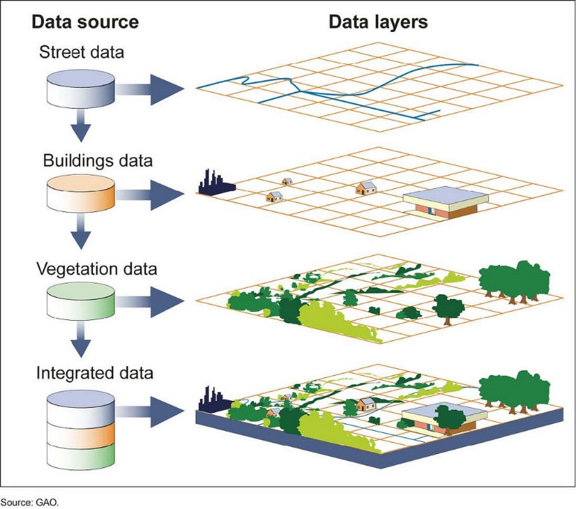

Figure 2.1 Geographic Information Systems (GIS)

### 2.3.1 ****GIS for Military Applications****

Geographic Information Systems (GIS) have been increasingly adopted in military operations due to their ability to enhance decision-making through detailed spatial analysis and real-time data integration. In military contexts, GIS is utilized for a variety of purposes, including terrain analysis, mission planning, asset tracking, and threat assessment. By integrating geospatial data with military-specific information, such as weapon ranges, troop movements, and weather patterns, GIS provides a comprehensive platform that supports the rapid and informed execution of operations.

For example, GIS allows military strategists to conduct detailed terrain analysis, identifying high ground, potential ambush sites, and movement corridors that would be crucial for mission planning. Furthermore, GIS can be used for route optimization, minimizing risk and maximizing operational efficiency in hostile environments

In addition to these tactical advantages, GIS also supports logistical operations. It helps with resource management by tracking supplies, personnel, and equipment, ensuring that assets are efficiently allocated across units. By leveraging GIS in military applications, decision-makers can make better-informed, data-driven decisions, improving mission success and reducing the likelihood of unforeseen challenges. [5]

### 2.3.2 GIS Data Models and Techniques

GIS relies on different data models and techniques for representing and analyzing spatial information. The most common data models used in GIS are vector and raster models, each serving different types of spatial data representation and analysis needs.

1. Vector Model: The vector model represents geographic features using points, lines, and polygons. This model is suitable for representing discrete features such as roads, buildings, boundaries, and other man-made or natural entities. In the context of military operations, vector data is essential for representing key features of the terrain, such as roads, rivers, and borders, as well as operational assets like military bases and strategic locations.
2. Raster Model: The raster model represents spatial data in a grid format, where each cell (or pixel) contains a value corresponding to a specific attribute, such as elevation, temperature, or land cover. Raster data is often used for continuous surfaces, such as elevation models, climate data, and satellite imagery.

Other techniques within GIS include spatial analysis, which involves examining the relationships between different geographical features, and geostatistical analysis, which applies statistical methods to spatial data to identify patterns or predict future events. Techniques such as buffer analysis, overlay analysis, and network analysis are commonly used in military GIS applications to assess risks, optimize routes, and make decisions about asset deployment. [5]

### 2.3.3 GIS and Real-Time Data Integration

The integration of real-time data with GIS has revolutionized its application in dynamic environments, such as military operations, disaster management, and urban planning. Real-time data, sourced from various devices and sensors such as GPS, UAVs, and satellites, can be integrated into GIS platforms to provide up-to-date situational awareness and enhance decision-making processes.

In military contexts, real-time GIS data integration is critical for operations such as troop movement tracking, battlefield surveillance, and sensor fusion. The use of real-time data allows for the continuous monitoring of changing conditions on the ground, such as enemy troop movements, weather shifts, or supply status. This integration provides military commanders with the ability to adapt rapidly to emerging threats or changes in the operational environment, improving both tactical responsiveness and strategic planning.

Real-time GIS also plays a vital role in communication between units, facilitating collaboration and information sharing in real time. For example, commanders in the field can upload positional data from mobile devices or drones to the central GIS system, providing other team members with a live, synchronized operational picture. In turn, this allows for quicker decision-making, more coordinated actions, and a higher likelihood of mission success. The ability to integrate real-time data into GIS systems also supports predictive analysis, enabling military forces to anticipate potential threats and adjust plans accordingly.

Together, these GIS capabilities enable enhanced operational effectiveness in complex, time-sensitive situations, making it an indispensable tool for modern military forces. The continued advancement of GIS technologies, particularly in the areas of real-time data integration and analysis, is expected to further solidify its role in military strategy and decision support. [5]

## 2.4 Map Caching for Online and Offline Use

Map caching is a critical technique in geospatial applications, enabling efficient access to map data and enhancing the performance of mapping systems. By storing pre-rendered or pre-fetched map tiles locally, either temporarily or permanently, map caching ensures seamless user experiences in both online and offline environments. This capability is especially important for applications where consistent access to maps is essential, such as navigation, tactical planning, or field operations, regardless of network availability. [10]

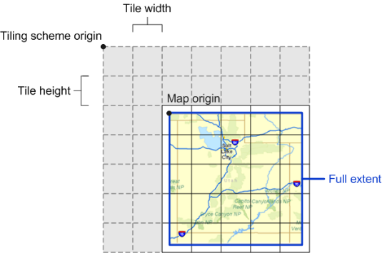

Figure 2.2 Map Caching with tiles

### ****2.4.1 Purpose of Map Caching****

1. **Improved Performance**: Map caching reduces the load time of map tiles by serving data from local storage rather than remote servers. This improves responsiveness, especially in environments with limited bandwidth or high latency.
2. **Offline Accessibility**: Offline map caching allows users to access critical map data without requiring an active internet connection, which is invaluable in remote or operationally constrained areas.
3. **Reduced Data Usage**: By reusing cached tiles, map caching minimizes data transfer requirements, lowering costs and conserving bandwidth for users in metered or data-sensitive scenarios.
4. **Scalability**: Caching helps reduce the load on mapping servers, allowing them to serve a larger number of users efficiently during peak times. [10]

### ****2.4.2 Types of Map Caching****

1. **Client-Side Caching**: Map tiles are stored locally on the user's device. This approach is common in mobile applications where users may need offline access to specific map regions.
2. **Server-Side Caching**: Frequently requested map tiles are cached on intermediary servers to accelerate delivery to end-users and reduce server load.
3. **Hybrid Caching**: Combines client-side and server-side caching, leveraging local storage for personalized access while utilizing server caching for general map requests. [10]

### ****2.4.3 Implementation of Map Caching****

1. **Pre-Caching**: In pre-caching, map tiles for specific areas are downloaded and stored before they are needed. For example, users can select a region on a map for offline use, and the application will fetch and store all required tiles for that area.
2. **On-Demand Caching**: In this approach, tiles are cached dynamically as users navigate through the map. Frequently accessed tiles remain stored locally for reuse, reducing the need to re-fetch them from the server.
3. **Storage Management**: Efficient management of storage is crucial for map caching.
4. **Data Formats**: Cached tiles are often stored in formats like PNG or JPEG for raster maps or GeoJSON for vector maps. The choice of format impacts storage efficiency and rendering speed. [10]

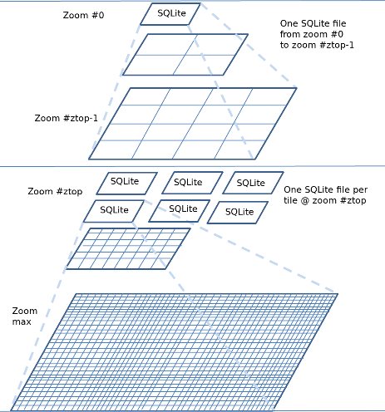

Figure 2.3 **Implementation of Map Caching**

### ****2.4.4** Online **and Offline Use Cases****

1. **Online Use**:
   1. Accelerates map rendering by retrieving tiles from the cache.
   2. Provides fallback options when the server is temporarily unavailable.
2. **Offline Use**:
   1. Essential for navigation apps in remote areas without cellular or internet access.
   2. Ensures military or disaster response teams have uninterrupted access to mission-critical map data in field operations. [10]

## 2.5 MBTiles Format for UTM Display

MBTiles is a file format that enables the storage of tilesets in a single SQLite database file. The key aspects of MBTiles include:

1. Tile Storage: It organizes tiles in a database structure, allowing quick access and efficient storage.
2. Offline Capabilities: By storing all map data in a single file, MBTiles provides developers with the ability to offer offline maps, making it ideal for mobile applications, navigation systems, and other use cases where connectivity can be a challenge.
3. Versatile Data Types: MBTiles can store both raster images (like JPEG and PNG) and vector data (like GeoJSON), making it a flexible solution for diverse mapping needs. [23]

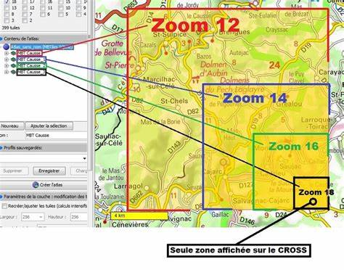

Figure 2.4 MBTiles Format display map with each zoom level

### 2.5.1 Understanding MBTiles Specification

The MBTiles specification defines the structure of the SQLite database used for storing tiles. This structure includes several tables, each with distinct purposes. At its core, the MBTiles schema consists of the following primary components:

1. Tiles Table: This is the heart of the MBTiles format. Each row corresponds to a tile, indexed by its zoom level, x, and y coordinates. The important columns in the tiles table include:
   1. zoom_level: Indicates the zoom level of the tile.
   2. tile_column: The x coordinate of the tile in the grid.
   3. tile_row: The y coordinate of the tile in the grid (noting that tile rows are flipped).
   4. tile_data: The binary data for the tile image itself, stored in a BLOB format.
2. Metadata Table: This table contains metadata that provides context about the tileset. It includes key-value pairs such as:
   1. name: The name of the tileset.
   2. description: A brief description of the tileset.
   3. format: Specifies the tile format (e.g., png, jpeg, vector).
   4. bounds: The geographic bounds of the tileset, represented as a bounding box in the form of min longitude, min latitude, max longitude, and max latitude.
3. Grid Table (optional): Some implementations of MBTiles may include a grid table that provides quick access to tile positions without needing to perform a full query on the tiles table. [23]

### 2.5.2 Tile Coordinate System

Understanding how the tile coordinates work is crucial for working with MBTiles. The coordinate system is based on the Web Mercator projection, which is widely adopted in web mapping. Here’s a brief breakdown:

1. Zoom Levels: The zoom level determines the resolution of the map. Higher zoom levels provide more detail but result in more tiles.
2. Tile Coordinates: For a given zoom level, the tile grid is organized such that the top-left tile has coordinates (0,0), the tile to the right has (1,0), and so forth. The y-coordinate increases downward, which is crucial to remember as it contrasts with traditional Cartesian coordinates. [23]

### **2.5.3** **Format Specifications**

In MBTiles 1.2, the format specifications for tile data, both raster and vector, are outlined clearly:

1. Raster Tiles: Stored as standard image formats such as PNG and JPEG, these tiles hold pixel-based data.
2. Vector Tiles: These are more complex and contain data encoded using formats like Mapbox Vector Tile (MVT). Vector tiles allow for dynamic styling on the client side, enhancing interactivity and user experience. [23]

## 2.6 Military Grid Reference System (MGRS)

The Military Grid Reference System (MGRS) is a geocoordinate standard used by NATO and various military organizations worldwide to pinpoint locations on the Earth’s surface with high precision. MGRS is based on the Universal Transverse Mercator (UTM) coordinate system, which divides the Earth into a series of 6° longitudinal zones. Each zone is further divided into grid squares, providing an easy-to-read, compact, and standardized method for referencing geographic locations. The system is widely used in military operations for mapping, navigation, and geospatial analysis, offering a consistent and universally accepted method of specifying locations in both tactical and operational environments. [20] [25]

MGRS coordinates are expressed as a combination of a zone number, a grid square identifier, and numerical coordinates. The grid reference consists of two parts: the **grid zone designator** and the **easting and northing coordinates**. The grid zone designator includes a letter (A-Z, except for I and O) to indicate the latitude band and a numeric zone number to specify the longitudinal zone. [14]

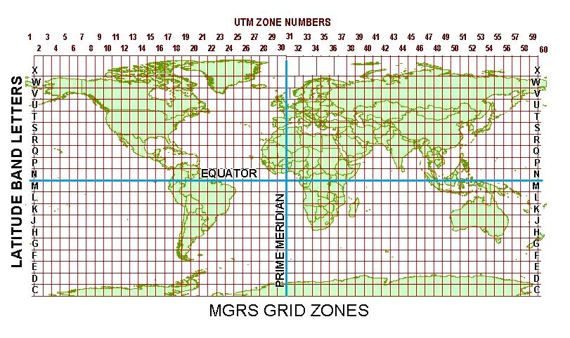

Figure 2.5 MGRS Grid Zone

### 2.6.1 ****Structure of MGRS Coordinates****

MGRS coordinates are typically structured in a hierarchical system that increases in precision as more digits are added to the reference. The general format for MGRS is as follows:

1. **Zone Number**: A two-digit number representing one of the 60 UTM zones, which span from 1 to 60, each covering 6 degrees of longitude.
2. **Latitude Band Letter**: A letter indicating the latitude zone, with the range of A to Z (excluding I and O), and each letter corresponding to a specific range of latitudes. For instance, "C" corresponds to latitudes between 80°S and 72°S, and "T" covers latitudes between 72°N and 84°N.
3. **Grid Square**: A two-letter identifier that divides each UTM zone into 100 km x 100 km grid squares. These squares are numbered from A to Z (except I and O), which increases precision and makes map reading easier.
4. **Easting and Northing**: These numbers provide the precise location within the grid square, with easting denoting the horizontal position (eastward from the origin) and northing denoting the vertical position (northward from the origin). [20] [21]

For example, a coordinate such as **33TWN1234567890** refers to a point located within the grid square "WN" in zone 33, with the last digits providing the specific position within that square. [21]

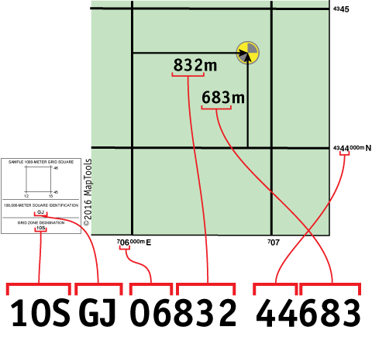

Figure 2.6 Components of MGRS

### 2.6.2 ****Advantages of MGRS for Military Applications****

MGRS provides numerous advantages for military operations, making it the preferred choice for navigation, planning, and coordination in the field:

1. **Global Standardization**: Since MGRS is a standardized system, it is used by various international military organizations, including NATO, which ensures interoperability between allied forces operating in different regions.
2. **High Precision**: MGRS coordinates can be specified with various levels of precision, from a broad zone-level reference (e.g., 1,000,000 meters) to highly detailed coordinates (down to a meter or even a centimeter in some cases). This flexibility allows for precision tailoring of location data, depending on mission requirements.
3. **Ease of Use**: The grid system used in MGRS is easier to read and work with compared to traditional latitude and longitude coordinates. MGRS simplifies the interpretation of geospatial data, especially in tactical scenarios where speed and clarity are critical.
4. **Compatibility with Mapping Tools**: MGRS is compatible with most modern mapping and navigation tools, including handheld GPS devices, digital maps, and military-specific software. This compatibility ensures that the system can be integrated into various technological platforms, enhancing operational efficiency.
5. **Efficiency in Combat Situations**: In military combat scenarios, the need for rapid communication of location data is paramount. The MGRS’s compact format makes it easier for soldiers to communicate coordinates over radio, in written reports, or in tactical discussions. This speed is crucial when coordinating movements, targeting, or support operations in fast-paced environments. [21]

### 2.6.3 ****Applications of MGRS in Military Operations****

MGRS is essential in numerous military applications, including:

1. **Navigation and Wayfinding**: Military units rely on MGRS for tactical navigation, whether on foot, in vehicles, or using air and naval forces. Accurate coordinates allow for precise movement, ensuring that units can reach designated locations without delay.
2. **Targeting and Fire Support**: MGRS is extensively used in artillery, airstrikes, and missile targeting. By using MGRS, military planners can ensure that targets are correctly identified and engaged, minimizing the risk of friendly fire and collateral damage.
3. **Geospatial Intelligence**: The system is used to gather, process, and analyze geospatial intelligence (GEOINT), which includes terrain features, enemy positions, and infrastructure. This information is vital for mission planning and for providing commanders with a comprehensive understanding of the operational environment.
4. **Logistics and Supply Chain Management**: MGRS coordinates are crucial for managing supply routes, staging areas, and resource distribution. They ensure that logistical operations are executed efficiently and that resources are allocated to the right locations at the right time.
5. **Situational Awareness**: MGRS enables real-time situational awareness on the battlefield, providing commanders and soldiers with accurate and easily interpretable information about their surroundings, including terrain, enemy activity, and friendly force positions. [20] [25]

## 2.7 LatLang (Latitude, Longitude) to MGRS Conversion

The conversion of geographic coordinates from latitude and longitude (LatLon) to the Military Grid Reference System (MGRS) is a critical process in geospatial applications, particularly in military operations. Latitude and longitude are expressed in a global coordinate system that defines a location based on angular measurements from the Earth’s center, while MGRS provides a grid-based system that simplifies positional references for tactical and operational purposes. The conversion ensures that data from sources like GPS devices, which typically output LatLon coordinates, can be utilized effectively within the MGRS framework for mapping, navigation, and situational awareness. [11]

### 2.7.1 ****The Need for LatLon to MGRS Conversion****

The LatLon coordinate system, based on the geographic grid of parallels and meridians, is versatile and universally recognized. However, it has limitations in military contexts where quick, concise, and precise communication of locations is essential. Latitude and longitude values are expressed in degrees, minutes, and seconds or decimal degrees, which can be cumbersome to interpret and relay in high-stress scenarios.

Conversely, MGRS is designed for operational simplicity, offering a grid-based approach that is compact, standardized, and easier to understand and communicate. The LatLon to MGRS conversion allows military personnel to leverage GPS technology while adhering to the MGRS standard, ensuring seamless integration across diverse systems and operational units. [11]

### 2.7.2 ****Conversion Process****

The LatLon to MGRS conversion involves several steps:

1. **Determine the UTM Zone**: Latitude and longitude coordinates are first used to identify the corresponding UTM (Universal Transverse Mercator) zone. The Earth is divided into 60 UTM zones, each spanning 6 degrees of longitude. For example, longitude 72°E would fall within UTM Zone 43.
2. **Identify the Latitude Band**: The latitude coordinate determines the latitude band, represented by letters (C to X, excluding I and O) that indicate specific ranges of latitude. For example, latitude 25°N corresponds to Band Q.
3. **Project Coordinates into UTM**: The LatLon values are projected into the UTM coordinate system using mathematical formulas that convert angular measurements into linear coordinates (easting and northing).
4. **Apply MGRS Grid Square Designation**: The UTM coordinates are further divided into 100 km x 100 km grid squares, each designated by a two-letter combination unique to the zone.
5. **Add Precision Digits**: The final step involves adding easting and northing digits to specify the exact location within the grid square. The number of digits depends on the desired precision (e.g., 1 meter, 10 meters, or 100 meters).

For example, the LatLon coordinates (25.2048°N, 55.2708°E) might be converted to an MGRS coordinate like **40RWR1234567890**, where "40" is the UTM zone, "R" is the latitude band, "WR" is the grid square, and the numerical values represent precise easting and northing positions. [11]

### ****2.7.3 Conversion from Latitude/Longitude to MGRS****

The conversion from latitude and longitude to the MGRS coordinate system involves the following steps: [3]

1. **Datum and Ellipsoid Definition:** The input lat/lng coordinates are referenced to a specific geodetic datum (e.g., WGS84).
2. **Determine UTM Zone:** The UTM zone is calculated based on longitude (λ):

 (2.1)

Where Z is the UTM zone number, λ is longitude in degrees, and ⌊x⌋ denotes the floor function.

1. **Project to UTM Coordinates:** The latitude (ϕ) and longitude (λ) are projected to UTM coordinates using the transverse Mercator projection. Key equations include:

 (2.2)

 (2.3)

Here:

λ: longitude relative to the central meridian of the UTM zone

k0​: scale factor (commonly 0.9996)

N: radius of curvature in the prime vertical

T: square of the tangent of latitude

C: ellipsoidal parameter

M: meridional arc length

1. **Determine MGRS Grid Square:** Divide the UTM coordinates into 100,000-meter grid squares. Identify the alphanumeric grid square based on the calculated Easting and Northing.
2. **Apply Latitude Band and Precision:** The latitude band (letters) is determined based on the latitude (ϕ), and the coordinate is rounded to the desired precision (e.g., 1 m, 10 m, 100 m).
3. **Final MGRS Representation**: MGRS=Z-Latitude Band-Grid Square-Easting-Northing, where Z is the UTM zone number, and the other components are calculated as described. [3]

## 2.8 Tactical Decision Support System (TDSS)

A Tactical Decision Support System (TDSS) is a specialized class of decision-support tools designed to assist military planners and commanders in making informed and timely decisions during operations. TDSS integrates advanced technologies, data analytics, and geospatial information to provide actionable insights, streamline operational planning, and enhance situational awareness in dynamic and high-stakes environments. By leveraging real-time data, predictive modeling, and simulation capabilities, TDSS serves as a critical component in modern military operations, enabling rapid adaptation to changing conditions on the battlefield.

TDSS operates by aggregating and processing data from multiple sources, such as satellite imagery, sensor networks, unmanned aerial vehicles (UAVs), and human intelligence. This data is analyzed to generate comprehensive visualizations and recommendations that help commanders evaluate different courses of action, assess risks, and optimize resource allocation. [7]



Figure 2.7 Tactical Decision-Making Process

### 2.8.1 ****Key Components of TDSS****

The key components of TDSS are:

1. **Data Integration and Fusion**: TDSS collects data from various sources, including geospatial databases, weather forecasts, and reconnaissance systems. The system uses advanced data fusion techniques to combine disparate data streams into a cohesive operational picture, reducing information overload and improving clarity.
2. **Geospatial Analysis**: One of the core features of TDSS is its ability to analyze spatial data. By integrating Geographic Information Systems (GIS), the system provides detailed terrain analysis, route optimization, and visibility assessments, which are essential for mission planning and execution.
3. **Simulation and Modeling**: TDSS incorporates simulation tools to model potential scenarios and predict outcomes based on different variables. This capability allows commanders to evaluate the impact of their decisions before implementing them, minimizing risks and ensuring mission success.
4. **Real-Time Decision Support**: The system uses real-time data feeds to provide up-to-date recommendations and alerts. This feature is particularly critical in fast-paced environments where delays in decision-making can have significant consequences.

**User Interface and Visualization**: TDSS includes intuitive dashboards and interactive maps that allow users to visualize complex data in an understandable format. This visualization aids in quick interpretation and better communication among team members. [7]

### 2.8.2 ****Applications of TDSS in Military Operations****

The following are the applications of TDSS in military operations:

1. **Mission Planning and Execution**: TDSS supports the planning phase by analyzing operational constraints, such as terrain, weather, and enemy positions. It generates optimized strategies and assists in coordinating troop movements, logistics, and resource deployment.
2. **Threat Assessment**: By analyzing enemy capabilities, movements, and potential threats, TDSS helps commanders anticipate and mitigate risks. This proactive approach enhances operational security and mission effectiveness.
3. **Fire Support Coordination**: TDSS integrates targeting systems with geospatial data to ensure precise delivery of fire support, minimizing collateral damage and increasing the likelihood of mission success.
4. **Logistics and Supply Chain Management**: The system aids in planning supply routes, monitoring resource consumption, and ensuring the timely delivery of critical supplies to operational units.
5. **Situational Awareness**: TDSS enhances situational awareness by providing a comprehensive and real-time view of the battlefield. This capability allows commanders to make informed decisions, even in highly complex and rapidly evolving scenarios. [7]

### 2.8.3 ****Advantages of TDSS****

The advantages of TDSS are:

1. **Enhanced Decision-Making**: TDSS reduces the cognitive burden on commanders by automating data processing and providing clear, actionable recommendations.
2. **Improved Efficiency**: By streamlining operational planning and execution, TDSS minimizes delays and optimizes resource utilization.
3. **Scalability**: TDSS can be adapted to various operational scales, from small tactical units to large-scale joint operations, making it versatile for different mission requirements.
4. **Integration with Modern Technologies**: The system can seamlessly integrate with emerging technologies, such as artificial intelligence (AI), machine learning, and the Internet of Things (IoT), further enhancing its capabilities. [7]

## 2.9 Distance Calculation from One Place to Another

The Haversine formula is a mathematical equation used to calculate the great-circle distance between two points on the Earth's surface based on their latitude and longitude. It considers the Earth as a sphere, making it highly accurate for most purposes. The formula is expressed as:

 (2.4)

 (2.5)

 (2.6)

Where:

ϕ1, ϕ2 ​: Latitudes of the two points (in radians).

Δϕ: Difference in latitudes (ϕ2−ϕ1​).

Δλ: Difference in longitudes (λ2−λ1).

R: Radius of the Earth (approximately 6371 km).

This formula calculates the shortest distance between two locations along the Earth's surface. [22]

## 2.10 Bearing Calculation on a Map from One Place to Another

Bearing is a crucial concept in navigation and geospatial analysis, representing the direction from one point to another on a map relative to a reference direction, typically true north.

Bearings are expressed in degrees (°) or mils, with degrees being the standard unit in civilian navigation and mils being commonly used in military operations for their finer granularity. [14]

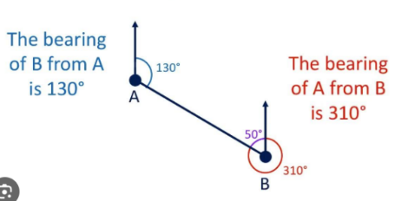

Figure 2.8 Bearing Calculation on a Map from One Place to Another

### 2.10.1Convert to Degrees

To calculate the bearing between two points in degrees, the geographic coordinates (latitude and longitude) of both points are required. Bearings are measured clockwise from true north and fall within the range of 0° to 360°. The process involves trigonometric calculations using the haversine formula or similar geospatial algorithms.

**Steps to Calculate Bearing in Degrees:**

1. **Define the Coordinates**: Let Point A have coordinates (,) and Point B have coordinates (,). These values should be in decimal degrees. [14]
2. **Compute the Angular Difference in Longitude**:

 (2.7)

1. **Calculate the Bearing Using the Formula**:

 (2.8)

Here:

arctan 2(y, x) is the two-argument arctangent function, which calculates the angle in the correct quadrant.

The input coordinates are converted to radians for trigonometric functions.

1. **Convert the Bearing to Degrees**: The result from the formula is in radians. Convert it to degrees using:

 (2.9)

**Example**:

1. Point A:  = 34.0522,  = -118.2437 (Los Angeles)
2. Point B:  = 36.7783,  = -119.4179 (Fresno)

Using the above formula, the computed bearing might be approximately **330°**, indicating the direction from Los Angeles to Fresno relative to true north.[14]

### 2.10.2Convert to Mils

In military contexts, bearings are often expressed in mils, a unit of angular measurement where 1 mil equals 1/6400 of a circle (NATO standard). Mils offer finer precision than degrees, as there are 6400 mils in a full circle compared to 360 degrees.

To convert a bearing in degrees to mils:

 (2.10)

**Steps to Convert Degrees to Mils**:

1. Start with the bearing in degrees obtained from the previous calculation.
2. Multiply the bearing in degrees by the conversion factor **Example**:



If the bearing between two points is **330°**, the equivalent in mils is:

330 ⋅ 17.7778 ≈ 5866 mils

The bearing in mils is approximately **5866**, providing greater precision for military applications. [14]

## 2.11 Finding Suitable Weapons for a Single Target Using Euclidean Distance

In military applications, selecting the most suitable weapon for engaging a single target involves a combination of factors, including the weapon's range, precision, and operational context. A common mathematical approach for determining the suitability of a weapon is the use of the Euclidean distance formula. This technique calculates the straight-line distance between the weapon’s current position and the target’s location on map, ensuring precise selection within operational constraints.

The Euclidean distance between two points  and on a two-dimensional plane is given by:

 (2.11)

Where:

: Coordinates of the weapon.

: Coordinates of the target.

d: Distance between the weapon and the target.

This distance helps identify the weapon closest to the target, which may have operational advantages, such as reducing response time and improving accuracy. [17]

## 2.12 Weighted Scoring System in The Most Suitable Weapon Selection

In modern combat scenarios, the selection of effective weaponry is critical for achieving tactical and strategic objectives. The complexity of warfare requires a systematic approach to evaluating weapons based on multiple performance factors. A weighted scoring system provides a structured method to assess and compare weapons by assigning importance to key attributes such as blast radius, weapon availability, ammunition capacity, and rate of fire. By integrating these factors into a balanced formula, military strategists and game designers can optimize weapon selection to ensure sustained combat effectiveness, operational flexibility, and efficient resource utilization. This method acknowledges the nuanced trade-offs between firepower, sustainability, and adaptability in dynamic combat environments. [16]

1. Blast Radius (20% Impact): Blast radius determines a weapon's area of effect (AoE), directly influencing its ability to damage multiple targets simultaneously. While important, its impact is moderated to avoid over-prioritizing wide-area weapons in situations where precision might be needed. Military research emphasizes the role of area control and suppression tactics in combat scenarios. [2]
2. Weapon Amount (10% Impact): The number of available units of a weapon contributes to operational readiness and redundancy. More units provide greater flexibility in strategy and can compensate for potential losses. This aligns with logistical principles of force sustainment. [15]
3. Ammo Amount (60% Impact): A weapon's ammo capacity is given the highest weight due to its direct influence on sustained combat performance. Weapons with high ammunition availability can engage targets for longer durations without resupply, crucial in extended operations. [4]
4. Rate of Fire (10% Impact): While the rate of fire contributes to damage output, it must be balanced against ammo consumption. Higher firing rates can deplete ammo rapidly, potentially limiting long-term effectiveness. Therefore, a moderate weight ensures rapid-fire weapons are balanced with sustainable firepower. [19]
5. Balanced Scoring Formula: The following formula integrates these weighted factors to calculate the weapon's effectiveness:

 (2.12)

## 2.13 Pathfinding with A* (A-Star) Algorithm and Barrier Avoidance

Pathfinding is a critical problem in computer science, robotics, game development, and navigation systems. It involves finding the most efficient path between two points while avoiding barriers. Efficient pathfinding is essential in applications like autonomous vehicle navigation, military route planning, and game AI. [12]

### 2.13.1 The A* (A-Star) Algorithm

The A* algorithm is one of the most widely used pathfinding algorithms because it efficiently finds the shortest path between two points in a weighted graph or grid. It combines the advantages of Dijkstra’s algorithm (which finds the shortest path) and Greedy Best-First Search (which quickly finds a path). [8]

 (2.13)

Where:

f(n) = Total estimated cost of the cheapest path through node n.

g(n) = Exact cost from the start node to node n.

h(n) = Heuristic estimated cost from node n to the goal.

Algorithm Steps:

1. Initialization: Add the starting node to an open list.
2. Selection: Choose the node with the lowest f(n) from the open list.
3. Expansion: Check all valid neighboring nodes.
4. Evaluation: Update the neighbor's cost if a better path is found.
5. Barrier Handling: Skip neighbors that are blocked by barriers.
6. Goal Check: If the goal node is reached, reconstruct the path.
7. Repeat: Continue until the open list is empty or the goal is reached.

### 2.13.2 Barrier Avoidance in A*

To navigate around Barriers, the search space is divided into a grid where each cell represents a section of the map. Cells are classified as either passable (0) or impassable (1). [8]

1. Barrier Representation:
2. Static Barriers: Buildings, mountains, lakes (always impassable).
3. Dynamic Barriers: Rivers with bridges (conditionally passable).
4. Expanded Barriers: Obstacles are expanded to simulate their area of influence.
5. Barrier Handling in A*:
6. Neighbors in impassable cells are ignored during path evaluation.
7. Bridges or special paths are modeled to allow selective movement.
8. Grid Representation: 0=Passable,1= Barrier

### 2.13.3 Heuristic Functions for A* Search Algorithm in Pathfinding

The heuristic guides the A* search by estimating the distance to the goal. Common heuristics include:

1. Manhattan Distance (for grid movement without diagonals):

 (2.14)

Where:

x1​, y1​: Coordinates of the current node.

x2, y2​: Coordinates of the goal node.

The absolute differences in x and y are summed, representing movement restricted to horizontal and vertical steps (no diagonal movement).

1. Euclidean Distance (for free movement):



Where:

This is the straight-line distance between two points, assuming unrestricted movement in any direction.

It is useful in environments where movement is not constrained to a grid (e.g., open terrain or continuous space).

1. Diagonal Distance (for diagonal and straight movement):

 (2.15)

Where:

When diagonal movement is allowed with the same cost as horizontal or vertical movement, the heuristic takes the larger difference between x and y coordinates.

This represents the number of diagonal moves needed to reach the goal efficiently.

The heuristic must be admissible (never overestimates the true cost) and consistent for the A* algorithm to guarantee the optimal path. [8]

## 2.14 Lanchester’s Square Law for decision making Feedback

Lanchester’s Square Law, a mathematical model developed during World War I, provides a quantitative approach to analyzing combat scenarios. It is particularly useful in decision-making for military operations, where understanding the relative effectiveness of opposing forces is critical. The law is based on the principle that the combat power of a force is proportional to the square of its size, assuming that each combatant is equally effective and engages its opponent uniformly. [6]

### ****2.14.1 Overview of Lanchester’s Square Law****

Lanchester’s Square Law is a fundamental mathematical model used to analyze and predict the outcomes of modern direct-fire combat scenarios. It is particularly applicable in situations where combatants are engaged in all-against-all targeting, meaning that every member of one force can potentially engage any member of the opposing force. This law provides a quantitative framework for understanding the dynamics of attrition in combat, emphasizing the interplay between the size of opposing forces and their respective combat effectiveness.

The law is expressed through a system of differential equations that describe the rate at which each force is depleted over time. These equations are given by:

 (2.16)

Where:

F represents the size of Force F (e.g., friendly forces).

S represents the size of Force S (e.g., enemy forces).

eS​​ denotes the effectiveness of Force S’s firepower, which quantifies the rate at which Force S can inflict casualties on Force F.

eF denotes the effectiveness of Force F's firepower, which quantifies the rate at which Force F can inflict casualties on Force S.

Lanchester’s Square Law highlights the critical importance of both numerical superiority and combat effectiveness in determining the outcome of an engagement. Specifically, the law suggests that the force with a larger size and greater effectiveness in firepower will have a significant advantage, often leading to dominance in combat. This relationship is nonlinear, as the impact of numerical superiority is squared, meaning that even small differences in force size or effectiveness can lead to disproportionately large differences in outcomes. [6]

The implications of Lanchester’s Square Law are profound for military strategy and operational planning. It underscores the necessity of maintaining not only sufficient troop numbers but also ensuring that forces are equipped and trained to maximize their combat effectiveness. This insight is pivotal for assessing combat readiness, optimizing resource allocation, and making informed decisions about strategic deployment. By applying this law, military planners can better predict the outcomes of potential engagements and develop strategies that leverage numerical and qualitative advantages to achieve victory.

In summary, Lanchester’s Square Law provides a robust theoretical foundation for understanding the dynamics of modern combat. Its emphasis on the interplay between force size and effectiveness makes it an invaluable tool for analyzing military engagements and informing strategic decision-making. As such, it remains a cornerstone of military science and operational research, offering critical insights into the factors that determine success in direct-fire combat scenarios. [6]

### ****2.14.2 Applications in Tactical Decision-Making Using**** Lanchester’s Law

The following are the applications in tactical decision-making using Lanchester’s Law:

1. **Resource Allocation**: Lanchester’s Law is instrumental in determining how to allocate limited resources, such as troops, vehicles, or artillery, to maximize combat effectiveness. By evaluating the relative strengths and weaknesses of opposing forces, commanders can decide on reinforcement priorities or optimal attack strategies.
2. **Simulation and Prediction**: Using the law, decision-makers can simulate various combat scenarios, predict outcomes, and test different strategies under controlled conditions. This enables preemptive adjustments to force composition or tactics before engagement.
3. **Strategic Planning**: The law helps in assessing whether a smaller, more technologically advanced force can counter a numerically superior adversary. This is particularly relevant in modern asymmetrical warfare scenarios, where advanced weaponry and tactics can offset disadvantages in size.
4. **Operational Efficiency**: By quantifying the relative impact of losses on both sides, Lanchester’s Square Law guides commanders in deciding when to escalate, retreat, or hold positions, ensuring optimal utilization of available resources. [18]

## 2.15 Literature Review

In [5], El-Gohary, M., & El-Rabbany has proposed “Applications of Geographic Information Systems (GIS) in Military Operations”. In that paper, their work emphasized how GIS enables real-time data visualization, precise location tracking, and effective resource allocation in complex operational environments. The study underlined applications such as terrain analysis, mission planning, and logistics management, demonstrating the technology’s capacity to provide commanders with actionable insights. Furthermore, the authors discussed the challenges of implementing GIS, including data accuracy, system interoperability, and the need for specialized training. This research underscores GIS as a critical tool for modern military operations, facilitating efficient, data-driven strategies that enhance operational effectiveness.

In [11], Karney, C. F. F has proposed “Transverse Mercator with an accuracy of a few nanometers. Journal of Geodesy”. In that paper, their work provided significant improvements over traditional methods, making it particularly useful for geodesy and cartography applications where accuracy is critical. By addressing computational inefficiencies and errors inherent in earlier models, the study offered a robust framework for mapping large-scale regions with minimal distortion. The methodology was validated through mathematical rigor and practical application, reinforcing its value in both scientific research and operational contexts where precise geospatial data is required.

In [3], Defense Mapping Agency have proposed “Technical Manual 8358.1: Datums, Ellipsoids, Grids, and Grid Reference Systems”. In that paper, they serve as a foundational reference for understanding datums, ellipsoids, grids, and grid reference systems essential for geospatial and mapping applications. It outlines the mathematical principles behind geographic datums and ellipsoidal models used to approximate the Earth's surface and discusses the application of grid systems, such as the Universal Transverse Mercator (UTM) and the Military Grid Reference System (MGRS), for precise location referencing. The manual is pivotal for ensuring interoperability and standardization in navigation and mapping, underscoring its significance in both tactical and strategic contexts.

In [7], Hale, M., & Davis, R. have proposed “The Role of Tactical Decision Support Systems in Modern Warfare”. In that paper, these systems integrate real-time data, advanced analytics, and predictive modeling to provide actionable insights for commanders, enabling rapid and informed responses. The study explores key features of TDSS, such as situational awareness, resource optimization, and scenario simulation, demonstrating their effectiveness in improving tactical outcomes. Furthermore, the authors discuss the challenges of integrating TDSS into existing military frameworks, including issues related to interoperability, data reliability, and user training. This research underscores the importance of TDSS in contemporary defense strategies, advocating for continued advancements to meet evolving battlefield demands.

In [14], NATO Standardization Office have proposed “The Glossary of Terms and Definitions (AAP-06)”. In that paper, that establishes standardized terminology across NATO member nations to ensure clarity and consistency in military communications and operations. It includes definitions and explanations for a broad range of terms used in strategic, operational, and tactical contexts, supporting interoperability and unified understanding among allied forces. By providing precise language for concepts such as command structures, operational strategies, and technical systems, the glossary enhances coordination and reduces misunderstandings during multinational exercises and missions. This comprehensive resource underscores NATO's commitment to fostering collaboration through a shared linguistic framework, critical in the context of rapidly evolving defense technologies and global security challenges.

In [20], Huang, B., & Liu, N. have proposed “Advances in Mobile Map Caching for Seamless Navigation”. In that paper, they highlight the critical role of adaptive caching algorithms in reducing latency and improving map availability, especially in areas with intermittent connectivity. Their research delves into various strategies, such as pre-fetching frequently used map tiles and dynamic cache management based on user behavior and geographic patterns. By leveraging these approaches, the study underscores the importance of efficient data usage, battery conservation, and uninterrupted user experience in modern mobile navigation systems. This work contributes to the broader field of geospatial services by addressing challenges related to real-time map rendering and offline usability, paving the way for more resilient and adaptive navigation applications.

In [21], NGA’s Office of GEOINT Sciences have proposed “Coordinate Systems Analysis Branch”. In that paper, one area of focus is the analysis and support of coordinate systems, which is crucial for ensuring precise geospatial referencing in military and operational contexts. The Coordinate Systems Analysis Branch, located in both St. Louis, MO, and Bethesda, MD, offers assistance in understanding and implementing various coordinate systems, helping to ensure consistency and accuracy across geospatial platforms. This support is critical for enhancing navigation, mapping, and tactical decision-making processes, particularly in defense and intelligence operations.

In [17], Sharma, R., & Aggarwal, S. have proposed “Applications of Distance Measurement in Military Targeting”. In that paper, they explore the critical role of distance measurement in military targeting, emphasizing its applications in enhancing precision, efficiency, and strategic decision-making. The authors review various geospatial technologies and methodologies employed to calculate distances for targeting purposes, including GPS, laser rangefinders, and advanced satellite imaging. They discuss how accurate distance estimation improves weapon deployment, minimizes collateral damage, and supports tactical planning. Additionally, the study highlights challenges such as terrain variability, environmental factors, and technological limitations, proposing potential solutions like integrated sensor networks and real-time data analysis. The article underscores the growing importance of geospatial science in modern warfare and its impact on operational success.

In [16], Saaty, T. L. has proposed “The Analytic Hierarchy Process”. In that paper, that introduced a groundbreaking decision-making framework that integrates quantitative and qualitative criteria into a structured evaluation model. This hierarchical methodology allows complex decisions to be broken down into smaller, more manageable parts, enabling decision-makers to compare elements pairwise and assign relative importance through numerical scales. Widely adopted across disciplines, the AHP facilitates prioritization and resource allocation, particularly in fields like operations research, strategic planning, and engineering. Its mathematical rigor and flexibility make it a powerful tool for multi-criteria decision-making, fostering systematic evaluation and consistent judgment in scenarios where competing alternatives and objectives must be balanced.

In [6], Epstein, J. M. has proposed “The Calculus of Conventional War: Dynamic Analysis Without Lanchester Theory”. In that paper, that critically examines traditional models of combat, specifically challenging the applicability of Lanchester’s equations for analyzing conventional warfare. Epstein argues that Lanchester’s deterministic models, which primarily focus on force-on-force attrition, oversimplify the complex dynamics of real-world combat by neglecting critical factors such as terrain, force dispersal, logistics, morale, and command structures. To address these limitations, Epstein introduces alternative dynamic modeling approaches that incorporate spatial and temporal variability, allowing for more realistic simulations of battlefield interactions. His work emphasizes the need for adaptive and nonlinear models to better represent the unpredictability and strategic complexity of modern warfare.

In [8], Hart, P. E., Nilsson, N. J., & Raphael, B. have proposed “A Formal Basis for the Heuristic Determination of Minimum Cost Paths”. In that paper, that introduced the A* (A-Star) algorithm, a groundbreaking approach to pathfinding and graph traversal. The A* algorithm effectively combines the strengths of Dijkstra's algorithm, which guarantees the shortest path by considering the exact cost from the start node, and the Greedy Best-First Search, which prioritizes nodes based on their estimated cost to the goal. This hybrid approach is achieved through the evaluation function f(n)=g(n)+h(n), where g(n) represents the exact cost from the start node to a given node n, and h(n) is a heuristic that estimates the cost from n to the goal. Their work laid the theoretical foundation for heuristic search algorithms and has since become a cornerstone in various fields, including artificial intelligence, robotics, and computer games, where efficient and optimal pathfinding is essential.

## 2.16 Summary

This chapter explored the foundational concepts and technologies essential for developing a military tactical support system. It began by discussing the importance of Flutter for building cross-platform mobile applications, followed by an in-depth analysis of Geographic Information Systems (GIS) and their role in spatial data visualization. The Military Grid Reference System (MGRS) and latitude/longitude conversion techniques were detailed to highlight their relevance in precise geolocation for tactical operations. Bearing calculations in both degrees and mils were explained to enable accurate directional assessments, while the significance of Tactical Decision Support Systems (TDSS) was underscored for informed decision-making in mission-critical scenarios. Finally, the role of map caching for online and offline applications was examined, emphasizing its contribution to seamless navigation and operational efficiency in diverse environments. Together, these components provide the technical foundation for implementing a robust geospatial system to support military operations.

# CHAPTER 3

# SYSTEM DESIGN AND IMPLEMENTATION

This chapter includes the proposed system architecture, overall design of the system, detail design for admin, detail design for user, proposed system design for database, implementation and results.

## 3.1 Proposed System Architecture of Android Application

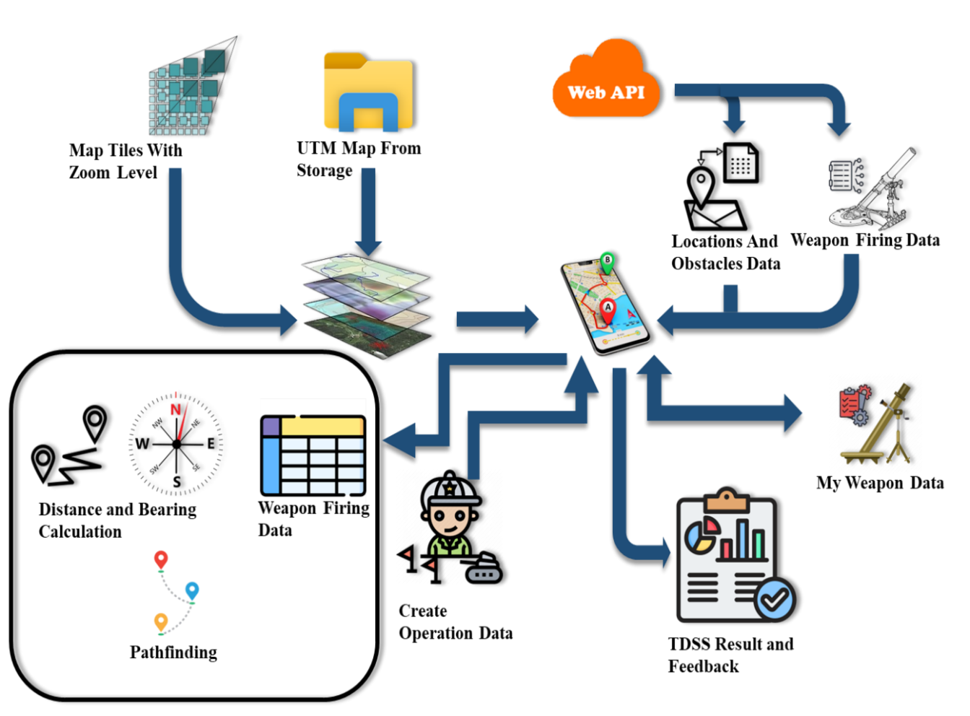

Figure 3.1 Overall System Design for Military Tactical Support System

The figure 3.1 illustrates a proposed system architecture that integrates various components, including map tiles, web APIs, local storage, and weapon firing data, to provide an interactive mobile-based geospatial decision support system. It highlights workflows for data collection, visualization, and analysis, facilitating decision-making in military or tactical scenarios.

## 3.2 Overall Design of the System



Figure 3.2 Detail Design of the System

The figure 3.2 shows the overall design of the system, illustrating user and admin functionalities integrated with a central database. Users can interact with map displays, add weapons, view geospatial data, and perform operations like converting coordinates to MGRS format, calculating distances, and determining suitable weapons within range. Admins manage users, locations, obstacles, and weapon specifications to ensure the system operates effectively. The system supports advanced capabilities, including route pathfinding using the A* algorithm, weapon firing range visualization, and battle calculations based on Lanchester's Square Law, with results stored and fed back for decision support.

## 3.3 Detail Design for Admin



Figure 3.3 Flow Chart for Admin

The figure 3.3 shows a detailed design for the admin module, starting with registration and login functionality for accessing the system. It allows admins to manage critical aspects of the system, such as users, locations, obstacles, and weapon specifications, utilizing a web API and a central web database for seamless operations.

## 3.4 Detail Design for User



Figure 3.4 Flow Chart for User

The figure 3.4 shows the detailed design workflow for a user interacting with the Tactical Decision Support System (TDSS). The process begins with user authentication, involving either registration or login, with verification through randomly generated questions. Once authenticated, the user can access the map display and input weapon data, which integrates geospatial data, positional tracking, and weapon specifications via a Web API. The system processes this data by converting coordinates, calculating distances, identifying suitable weapons, and simulating battles using Lanchester's Square Law. Finally, the system provides strategic feedback and optimal pathfinding using the A* algorithm to support dynamic tactical decision-making.

## 3.5 Proposed System Design for Database

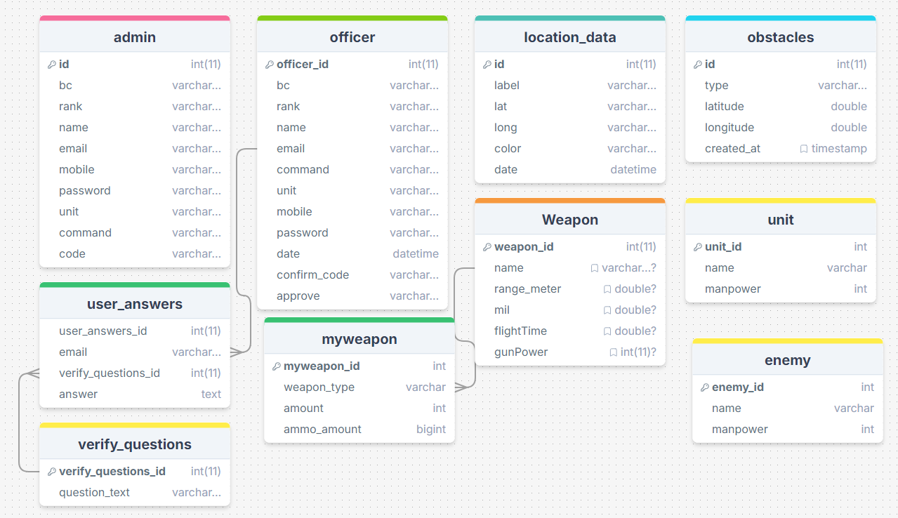

Figure 3.5 Database Design of The System

The figure 3.5 shows the proposed database design for the Tactical Decision Support System (TDSS), showcasing the relationships between key entities. The admin and officer tables store user credentials and role-specific information, enabling secure access control and management of system users. The location_data and obstacles tables handle geospatial data, capturing positional information and obstacle details for tactical analysis. The Weapon and myweapon tables manage weapon specifications and user-specific weapon inventories, linking directly to operational data. Additionally, the unit and enemy tables store force composition data, supporting simulation models, while the user_answers and verify_questions tables ensure secure authentication through verification questions.

## 3.6 Example: Distance Calculation from Pyin Oo Lwin to Mandalay

Let’s compute the distance between **Pyin Oo Lwin** (latitude: 22.0355, longitude: 96.4583) and **Mandalay** (latitude: 21.9759, longitude: 96.0844) using **Haversine formula:**

1. Step 1: Define the coordinates
2. Pyin Oo Lwin: ϕ1= 22.0355∘, λ1= 96.4583∘
3. Mandalay: ϕ2 = 21.9759∘, λ2 = 96.0844∘
4. Step 2: Convert degrees to radians

To compute trigonometric functions, we convert the latitudes and longitudes from degrees to radians:

Radians = Degrees ×

1. ϕ1 = 22.0355 × = 0.384521radians
2. λ1 = 96.4583 × = 1.683155radians
3. ϕ2 = 21.9759 × = 0.383502radians
4. λ2 = 96.0844 × $\frac{π}{180}$ = 1.677602radians
5. Step 3: Compute Δϕ and Δλ
6. Δϕ = ϕ2 − ϕ1 = 0.383502 − 0.384521 = −0.001019radians
7. Δλ = λ2 − λ1 = 1.677602 − 1.683155 = −0.005553radians
8. Step 4: Compute a using the Haversine formula



1. Compute :



sin(−0.0005095)=−0.0005095(for small angles, sin(x) ≈ x)

sin2(−0.0005095) = (−0.0005095)2 = 2.596 × 10−7

1. Compute :



sin (−0.0027765) = −0.0027765

sin2(−0.0027765) = (−0.0027765)2 = 7.707 × 10−6

1. Compute cos(*ϕ*1)  cos(*ϕ*2):

cos (0.384521) = 0.926048, cos (0.383502) = 0.926219

cos(*ϕ*1)  cos(*ϕ*2) = 0.926048  0.926219 = 0.85789

1. Combine into *a*:

*a* = (2.596 × 10−7) + (0.85789 7.707 × 10−6) *a* = 2.596 × 10−7 + 6.614 × 10−6 = 6.874 × 10−6

1. Step 5: Compute *c*

$c=2.arctan 2 \left(\sqrt{a},\sqrt{1-a}\right)$

$\sqrt{a}$ = $\sqrt{6.874 × {10}^{-6}}$ = 0.002622

$\sqrt{1-a}$ = $\sqrt{1-6.874 × {10}^{-6}}$ = 0.999993 = 0.999997

c = 2⋅arctan2(0.002622,0.999997) = 2 ⋅0.002622 = 0.005244radians

1. Step 6: Compute the distance

Distance = *R $×$ c*

Distance = 6371 $×$ 0.005244 = 33.41kilometers

The distance between Pyin Oo Lwin and Mandalay is approximately 33.41 kilometers.

## 3.7 Example: Bearing Calculation from Pyin Oo Lwin to Mandalay

Let’s compute the bearing from **Pyin Oo Lwin** (latitude: 22.0355, longitude: 96.4583) to **Mandalay** (latitude: 21.9759, longitude: 96.0844) using bearing formula:



1. **Step 1: Define the given coordinates**
2. Pyin Oo Lwin: ϕ1=22.0355∘, λ1=96.4583∘
3. Mandalay: ϕ2=21.9759∘, λ2=96.0844
4. **Step 2:** Convert degrees to radians: To compute trigonometric functions, we first convert the latitude and longitude values from degrees to radians:

Radians = Degrees ×

1. ϕ1 = 22.0355 × = 0.384521radians
2. λ1 = 96.4583 × = 1.683155radians
3. ϕ2 = 21.9759 × = 0.383502radians
4. λ2 = 96.0844 × $\frac{π}{180}$ = 1.677602radians
5. **Step 2:** ComputeΔ2

Δ2 = λ2 − λ1 = 1.677602 − 1.683155 = −0.005553radians

1. Step 4: Compute components for arctan2 and calculate the values of *x* and *y* in the bearing formula:
2. x = sin (Δλ) ⋅ cos(ϕ2)

x = sin (−0.005553) ⋅ cos (0.383502)

Using a calculator:

sin (−0.005553) = −0.005553

cos (0.383502) = 0.926219

x = −0.005553 ⋅ 0.926219 = −0.005143

1. *y* = cos(*ϕ*1)⋅ sin(*ϕ*2)− sin(*ϕ*1)⋅ cos(*ϕ*2)⋅ cos(Δ*λ*) *y* = cos(0.384521) ⋅ sin(0.383502) − sin(0.384521) ⋅ cos(0.383502) ⋅ cos(−0.005553)

Using a calculator:

cos (0.384521) = 0.926048

sin (0.383502) = 0.373208

sin(0.384521) = 0.374748

cos(−0.005553) = 0.999985

*y* = (0.926048 ⋅ 0.373208) − (0.374748 ⋅ 0.926219 ⋅ 0.999985)

*y* = 0.345730 − 0.347308 = −0.001578

1. Step 5: Compute θ using arctan2

θ = arctan2(x, y) = arctan2(−0.005143, −0.001578)

Using a calculator:

θ = arctan2(−0.005143, −0.001578) = −1.309206radians

1. Step 6: Convert *θ* to degrees

Convert radians to degrees:

Radians = Degrees × $\frac{π}{180}$

θ = -1.309206 × $\frac{π}{180}$ =-75.02 $°$

1. Step 7: Normalize the bearing

Add 360 to ensure the bearing is within 0 to 360:

Bearing = (−75.02 + 360) mod 360 = 284.98

Final Answer: The initial bearing from Pyin Oo Lwin to Mandalay is approximately 285.0° (northwest direction).

## 3.8 Example: Latitude/ Longitude Coordinate to MGRS Conversion

To convert the latitude/longitude coordinates of Pyin Oo Lwin (latitude: 22.0355, longitude: 96.4583) into the **Military Grid Reference System (MGRS)** format, follow these step-by-step calculations:

1. Step 1: Determine UTM Zone :

Pyin Oo Lwin is located at latitude: 22.0355, longitude: 96.4583.

$UTM Zone=\left[\frac{Longitude+180}{6}\right]+1$

$UTM Zone=\left[\frac{96.4583+180}{6}\right]+1=\left[46.076\right]+1=47$

So, Pyin Oo Lwin lies in UTM Zone 47.

1. Step 2: Hemisphere

Since Pyin Oo Lwin is in the Northern Hemisphere (latitude: 22.0355), we use the Northern Hemisphere.

1. Step 3: Latitude Band

The latitude bands are divided in 8-degree increments. For Pyin Oo Lwin (latitude: 22.0355°), it falls into the latitude band Q.

Latitude Band = Q.

1. Step 4: Convert Latitude and Longitude to UTM Coordinates

Using the WGS84 ellipsoid and precise conversion methods, the approximate UTM coordinates for Pyin Oo Lwin are:

Easting (X): 394,630 meters

Northing (Y): 3,852,400 meters

These are the precise Easting and Northing values in UTM.

1. Step 5: Determine MGRS Grid Square

The MGRS system divides the UTM zone into 100,000-meter squares. The letters identifying the grid square are determined by the Easting and Northing values:

For Easting: 394,630 meters, this corresponds to KE.

For Northing: 3,852,400 meters, this corresponds to KE.

Thus, the Grid Square is KE.

1. Step 6: Add Precision

MGRS coordinates add precision by dividing each 100,000-meter square into smaller 10-meter squares. For Easting: 394,630 meters and Northing: 385,240 meters, we break down these values into 5digit numbers for 10-meter precision.

The MGRS coordinates for Pyin Oo Lwin, with precision, are:47Q KE 39463 38524. This is the MGRS location for Pyin Oo Lwin with 10-meter precision.

## 3.9 Example Calculation for Selection The Most Suitable Weapon

To illustrate the process of selecting the most suitable weapon, we evaluate three weapons: MA7, MA8, and 120MM. The evaluation uses a weighted scoring formula that incorporates key performance factors such as blast radius, weapon availability, ammunition capacity, and rate of fire.

1. Weapon Data: The weapon details are summarized as follows:

Table 3.1 All Suitable Weapon Data

|  |  |  |  |  |  |  |  |
| --- | --- | --- | --- | --- | --- | --- | --- |
| Weapon | Gun Power | Flight Time | Mil | Blast Radius | Rate of Fire | Weapon Amount | Ammo Amount |
| MA7 | 200 | 5 | 10 | 15.0 | 18 | |  | | --- | |  |  |  | | --- | | 5 | | 150 |
| MA8 | 250 | 6 | 12 | 35.0 | 20 | 3 | 100 |
| 120MM | 300 | 8 | 15 | 100.0 | 10 | 2 | 50 |

1. Scoring Formula: The scoring formula integrates weighted importance factors to calculate the overall effectiveness of each weapon:



This formula prioritizes sustained combat performance by emphasizing ammunition capacity (60%), followed by blast radius (20%), weapon availability (10%), and rate of fire (10%).

1. Calculations
2. MA7:

ScoreMA7 = ≈1.27

1. MA8:

ScoreMA8= ≈1.99 

1. 120MM:

Score120mm= ≈ 6.44

1. Results and Selection: Based on the calculations:
2. MA7: Score = 1.27
3. MA8: Score = 1.99
4. 120MM: Score = 6.44

The weapon 120MM is determined to be the most suitable option due to its highest score of 6.44, indicating superior overall effectiveness. This selection reflects its excellent balance of firepower, sustained operational capability (ammunition availability), and strategic adaptability, making it ideal for the given combat scenario.

## 3.10 Example Calculation: Battle Results for TDSS Feedback

This section demonstrates a step-by-step calculation of battle results using Lanchester's Law. The example involves two friendly units, two enemy units, and mortars with different attributes for each side.

1. Unit Side (Our Forces):
   1. Total Manpower (B0): 5000 soldiers
   2. Weapon Factors:

Weapon Type A: Blast Radius = 1.2, Rate of Fire = 3, Ammo = 2000, Weapon Type B: Blast Radius = 1.5, Rate of Fire = 2, Ammo = 1500

* 1. Terrain Factor: 1.0
  2. Weather Factor: 1.0
  3. Operational Factor: 0.8
  4. Intangible Factor: 0.9

1. Enemy Side:
2. Total Manpower (R0): 6000 soldiers
3. Weapon Factors:

Weapon Type X: Blast Radius = 1.1, Rate of Fire = 2, Ammo = 2500

Weapon Type Y: Blast Radius = 1.3, Rate of Fire = 3, Ammo = 1800

1. Terrain Factor: 0.8
2. Weather Factor: 0.9
3. Operational Factor: 0.7
4. Intangible Factor: 0.85

### 3.10.1 Step 1: Calculate Force Strength

1. Unit Side Force Strength Calculation:

Using the formula:

FS = ∑ (Ammo × Blast Radius × Rate of Fire × Terrain Factor × Weather Factor)

1. For Weapon Type A:

FSA = 2000 × 1.3 × 3 × 1.0 × 1.0 = 7200

1. For Weapon Type B:

FSB = 1500 × 1.5 × 2 × 1.0 × 1.0 = 4500

1. Total Unit Force Strength:

FSunit = 7200 + 4500 = 11700

1. Enemy Side Force Strength Calculation:

Using the formula: FS = ∑ (Ammo × Blast Radius × Rate of Fire × Terrain Factor × Weather Factor)

1. For Weapon Type X:

FSX = 2500 × 1.1 × 2 × 0.8 × 0.9 = 3960

1. For Weapon Type Y:

FSY = 1800 × 1.3 × 3 × 0.8 × 0.9 = 5054

1. Total Unit Force Strength:

FSenemy = 3960 + 5054 = 9014

### 3.10.2 Step 2: Calculate Combat Potential

Using the formula:

CP = (Manpower × Manpower Weight) + (Force Strength × Weapon Weight) + Operational Factor × Intangible Factor

Given weights:

Manpower Weight = 0.6

Weapon Weight = 0.4

1. Unit Side Combat Potential:

CPunit = (5000 × 0.6) + (11700 × 0.4) + 0.8 × 0.9

CPunit = (3000 + 4680) + 0.8 × 0.9 = 5529.6

1. Enemy Side Combat Potential:

CPenemy = (6000 × 0.6) + (9014 × 0.4) + 0.7 × 0.85

CPenemy = (3600 + 3605.6) + 0.7 × 0.85 = 4286.3

### 3.10.3 Step 3: Calculate Alpha and Beta Coefficients

$$α= \frac{{CP}_{unit}}{{CP}_{enemy}}$$

$$β= \frac{1}{α}$$

$$α= \frac{5529.6}{4286.3}=1.29 , β= \frac{1}{1.29}=0.78$$

### 3.10.4 Step 4: Calculate Battle Duration

1. Using Lanchester’s equation:
$$T= \frac{1}{2αβ} 1n \left(\frac{1+{βR_{0}}/{αB_{0}} }{1-{βR_{0}}/{αB_{0}}}\right) ×1000$$

2. Substituting values:
$$T= \frac{1}{2×1.29×0.78} 1n \left(\frac{1+\frac{0.78 ×6000}{1.29 ×5000}}{1-\frac{0.78 ×6000}{1.29 ×5000}}\right) ×1000$$

$$=0.498 1n \left(6.273\right)×1000=915.5 minutes$$

3. Converting to hours:

915.5 minutes = 15 hours, 15.5 minutes

### 3.10.5 Step 5: Calculate Remaining Forces

1. If unit wins:

Remaining Unit Forces = $B_{0}× \frac{{CP}_{unit}-{CP}_{enemy}}{{CP}_{unit}}$

= $5000× \frac{5529.6-4286.3}{5529.6}=1120$

1. If unit wins:

Remaining Enemy Forces = $R_{0}× \frac{{CP}_{enemy}-{CP}_{unit}}{{CP}_{enemy}}$

= $6000× \frac{4286.3-5529.6}{4286.3}$ = 0 (Units Win)

### 3.10.6 Step 6: Summary of Battle Results

Table 3.2 Summary of battle results

|  |  |
| --- | --- |
| Result | Value |
| Battle Duration (Units win) | 15 hours, 15.5 minutes |
| Battle Duration (Enemy wins) | Not applicable (Units win) |
| Remaining Unit Forces | 1120 soldiers |
| Remaining Enemy Forces | 0 (enemy eliminated) |
| Battle Outcome | Victory for Units |

This calculation highlights the application of Lanchester's Law when mortars are the primary weapons, showcasing how weapon attributes impact battle outcomes and strategic decision-making.

### 3.10.7 Step 7: Most Dangerous Enemy Calculation

The goal of this step is to identify the most dangerous enemy by calculating a Threat Score for each enemy. The Threat Score is a weighted combination of the enemy's manpower and weapon power. The formula for the Threat Score is:

Threat Score=(Manpower×0.3)+(Weapon Power×0.7)

Where: Manpower is the number of enemy troops, Weapon Power is calculated based on the enemy's weapon attributes:

1. Example Calculation

Let’s assume we have the following data for two enemies:

1. Enemy 1:

Manpower: 100

Weapon Type: "Rocket Launcher"

Ammo Amount: 50

Blast Radius: 2.5 (from blastRadiusMap)

Rate of Fire: 3 (from rateOfFireMap)

1. Enemy 2:

Manpower: 150

Weapon Type: "Machine Gun"

Ammo Amount: 200

Blast Radius: 1.0 (from blastRadiusMap)

Rate of Fire: 10 (from rateOfFireMap)

1. Step 1: Calculate Weapon Power for Each Enemy
2. Enemy 1:

Weapon Power=Ammo Amount×Blast Radius×Rate of Fire Weapon Power=50×2.5×3=375

1. Enemy 2:

Weapon Power=200×1.0×10=2000

1. Step 2: Calculate Threat Score for Each Enemy
2. Enemy 1:

Threat Score=(Manpower×0.3)+(Weapon Power×0.7) Threat Score=(100×0.3)+(375×0.7)=30+262.5=292.5

1. Enemy 2:

Threat Score=(150×0.3)+(2000×0.7)=45+1400=1445

1. Step 3: Compare Threat Scores
2. Enemy 1 Threat Score: 292.5
3. Enemy 2 Threat Score: 1445

Enemy 2 has a significantly higher Threat Score (1445) compared to Enemy 1 (292.5). Therefore, Enemy 2 is identified as the most dangerous enemy and should be targeted first.

## 3.11 Implementation

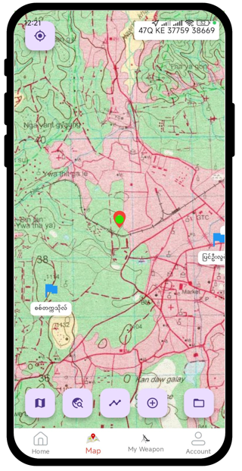

Figure 3.6 Map Integration for User and Admin with UTM Map

Figure 3.6 illustrates the integration of a map interface for both users and administrators using UTM Map, showcasing various marked locations and allowing the input of MGRS coordinates for navigation and interaction.

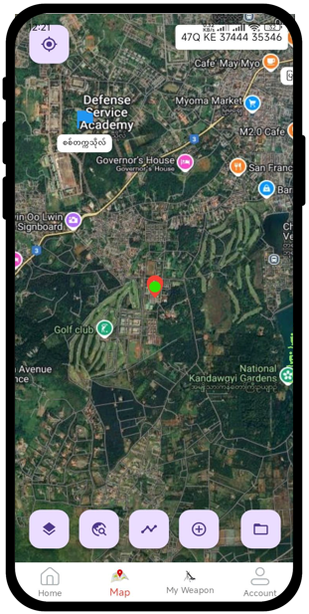

Figure 3.7 Map Integration for User and Admin with Google Hybrid Map

Figure 3.7 illustrates the integration of a map interface for both users and administrators using Google Hybrid Map, showcasing various marked locations and allowing the input of MGRS coordinates for navigation and interaction.

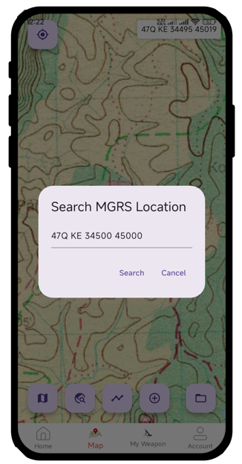

Figure 3.8 Search Locations by MGRS Format

Figure 3.8 illustrates a feature that allows users to search for specific locations using the MGRS (Military Grid Reference System) format, as shown on a detailed map interface.

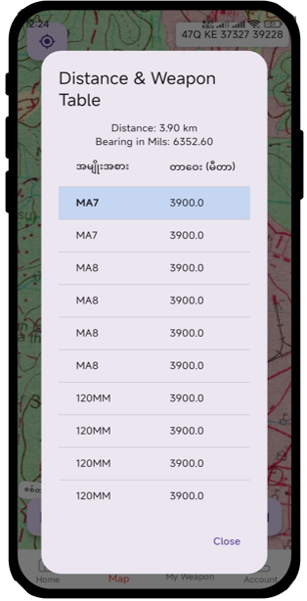

Figure 3.9 Calculate Distance, Bearing and Suitable Weapon for Set Target Two Points and for Current Location to Center Point

Figure 3.9 illustrates a map-based application calculating the distance, bearing, and a suitable weapon (e.g., MA7) for a set target between two points and current location, providing essential details such as the range and gun power.

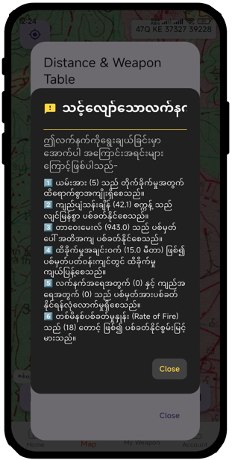

Figure 3.10 Give Feedbacks for Most Suitable Weapon

Figure 3.10 illustrates feedback for most suitable weapon within all weapons for a set target between two points and current location.

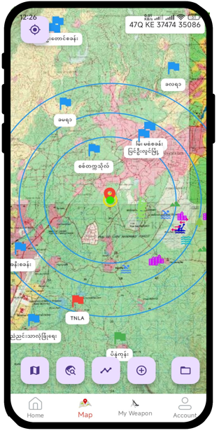

Figure 3.11 Draw Firing range for motor guns on map

Figure 3.11 illustrates a map-based application displaying the firing ranges of mortar guns as concentric circles, visually indicating their effective coverage areas around designated points.

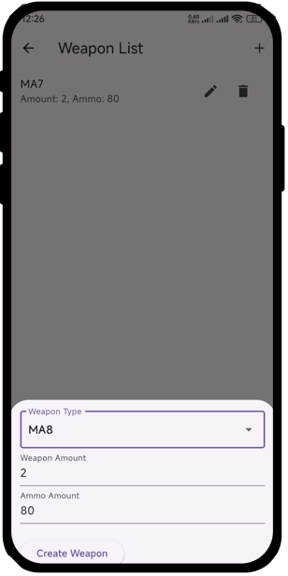

Figure 3.12 Add My Weapon Data to System

Figure 3.12 illustrates the "Add My Weapon" interface within the system, allowing users to select a weapon type, specify the weapon amount, and input the available ammunition.

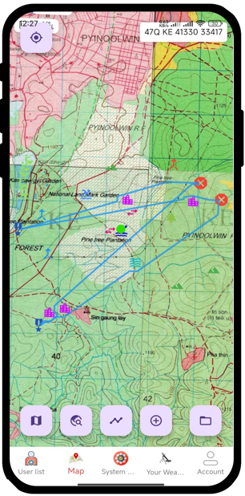

Figure 3.13 Drawing Routes Avoiding the Obstacles On map

Figure 3.13 illustrates the process of drawing routes on the map to strategically avoid obstacles such as forests and other terrain features. The blue routes connect key points while bypassing restricted areas, ensuring safe and efficient movement within the operational zone.

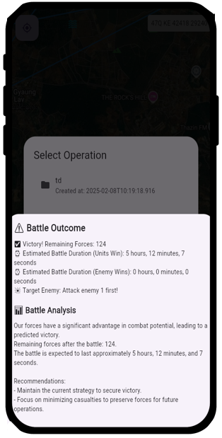

Figure 3.14 Display TDSS Feedbacks

Figure 3.14 demonstrates the Tactical Decision Support System (TDSS) feedback, providing crucial battle analysis details. It includes the battle outcome (victory or defeat), duration, remaining forces, and a recommended target for the next action, enhancing strategic decision-making.

## 3.12 Summary

In Chapter 3, the implementation of an automated dynamic weapon range visualization and engagement planning system for a military tactical support system using geospatial data was detailed. The chapter outlined the core functionalities of the system, including distance and bearing calculations, identification of suitable weapons based on range and firepower, and real-time visualization of firing ranges on geospatial maps. The system integrates features such as MGRS (Military Grid Reference System) location input, target setting, and visualization of firing zones for various weapon systems like mortars and artillery. These features enable precise tactical planning and enhanced situational awareness by leveraging geospatial data to optimize weapon deployment and engagement strategies. The integration of these tools provides a user-friendly and efficient interface for military operations.

# CHAPTER 4

# CONCLUSION

In conclusion, this research successfully designed and developed a Tactical Decision Support System (TDSS) that combines advanced geospatial mapping, efficient data management, and robust algorithms to enhance military decision-making. By integrating tools such as Google Hybrid Maps, UTM maps, and MGRS grids, the system provides users with precise location-based data for analyzing battle scenarios. Key functionalities include identifying suitable weapons based on range, calculating distances and bearings, and simulating realistic battle outcomes using Lanchester's Square Law. The use of a hybrid approach—leveraging local and web databases—ensures the system's reliability both online and offline. Furthermore, the implementation of pathfinding algorithms enables optimized movement planning, avoiding obstacles and enhancing operational efficiency.

This TDSS represents a significant step forward in modernizing military command systems by offering a comprehensive, user-friendly platform for tactical planning. The system not only simplifies complex computations but also provides actionable insights into battlefield dynamics, ensuring improved decision-making accuracy. By addressing challenges such as geospatial data integration, weapon range suitability, and dynamic obstacle avoidance, this research lays a strong foundation for future enhancements, such as integrating artificial intelligence for predictive analytics and real-time decision-making in rapidly changing battlefield conditions.

This research successfully developed a Tactical Decision Support System (TDSS) that integrates geospatial data, weapon specifications, and advanced algorithms to enhance military decision-making. The system provides precise location-based analysis, calculates distances and bearings, identifies suitable weapons, and simulates battle outcomes, ensuring efficient tactical planning. By addressing key challenges like barriers avoidance and offline functionality, this work lays a strong foundation for future enhancements, such as real-time predictive analytics and AI integration.

## 4.1 Advantages of the System

The proposed system offers several key advantages:

1. The system streamlines geospatial data analysis, distance calculations, and weapon selection, improving the speed and accuracy of military decision-making.
2. By integrating Google Hybrid Maps, UTM maps, and MGRS grids, the system provides precise and detailed mapping capabilities, allowing users to effectively visualize and manage positional data.
3. The combination of local map caching and web API integration ensures reliable operation in both offline and online environments, making the system adaptable to various operational scenarios.
4. Features such as weapon firing range visualization, distance and bearing calculations, and battle simulations using Lanchester’s Square Law enable users to predict and plan engagements with greater accuracy.
5. The implementation of the A* algorithm allows for optimal troop and equipment movement, avoiding obstacles and enhancing overall operational efficiency.
6. The system supports both user and administrator functionalities, enabling the addition and management of weapon data, locations, and obstacles, making it highly adaptable to diverse military needs.

## 4.2 Disadvantages of the System

Despite its strengths, the system has some limitations:

1. The system relies on map and API data, meaning any inaccuracies or outdated information can impact calculations and decision-making.
2. While web APIs provide geospatial and weapon data, the system does not currently support dynamic updates for moving units or changing battlefield conditions.
3. Although map caching allows offline access, it is restricted to pre-downloaded regions, which may not always include all operational areas.
4. Lanchester’s Square Law provides a mathematical model for battle outcomes but does not account for complex battlefield factors such as terrain influence or real-time unit interactions.
5. The A* algorithm for pathfinding and obstacle avoidance may become resource-intensive when handling large-scale operations with numerous units and barriers, potentially affecting performance.
6. The system currently lacks AI-driven models for anticipating enemy movements or suggesting optimal strategies, limiting its capability for real-time tactical decision-making.

## 4.3 Further Extensions

The proposed system can be further enhanced with the following extensions:

1. Incorporating real-time geospatial and battlefield updates, such as live unit positions and dynamic barriers, can improve decision-making accuracy and adaptability in rapidly changing scenarios.
2. Implementing AI-based predictive analytics can enable the system to anticipate enemy movements, recommend optimal strategies, and adapt to complex battlefield conditions.
3. Extending the battle simulation model to include factors like terrain effects, weather conditions, and unit-specific characteristics can provide more realistic and detailed outcome predictions.
4. Improving offline functionality by enabling preloading of larger map areas and critical data for broader regions would make the system more robust in areas with limited connectivity.
5. Adding support for multiple users to collaborate in real-time or simulate joint operations across multiple devices can enhance the system’s applicability in team-based scenarios.
6. Extending the system to support mobile devices and wearable technologies can improve accessibility and usability for on-field personnel during operations.
7. Developing a more robust offline mode that includes local computation of complex data and advanced mapping functionalities would increase the system’s reliability in remote or disconnected environments.
8. Incorporating a more extensive database of weapon specifications and unit types, along with detailed range and performance data, can improve the system’s versatility.

# REFERENCES

1. Boulter, S. (2009). *The Evolution of Military Mapping and Geographic Information Systems (GIS) for Tactical Decision Support*. Journal of Military Geospatial Intelligence, 6(2), 45-67.
2. Clausewitz, C. von. (1832). “*On War”.*
3. Defense Mapping Agency. (1989). “*Technical Manual 8358.1: Datums, Ellipsoids, Grids, and Grid Reference Systems”.*
4. Eccles, H. (1959). “*Logistics in the National Defense”.*
5. El-Gohary, M., & El-Rabbany, A. (2011). Applications of Geographic Information Systems (GIS) in Military Operations. “*Proceedings of the 2011 International Conference on Military Communications and Information Systems (ICMCIS)”* (pp. 1-6). IEEE.
6. Epstein, J. M. (1985). “*The Calculus of Conventional War: Dynamic Analysis Without Lanchester Theory”.* Brookings Institution.
7. Hale, M., & Davis, R. (2020). “*The Role of Tactical Decision Support Systems in Modern Warfare”*. Defense Technology Journal*, 14(3),* 213-225.
8. Hart, P. E., Nilsson, N. J., & Raphael, B. (1968). “*A Formal Basis for the Heuristic Determination of Minimum Cost Paths”*. IEEE Transactions on Systems Science and Cybernetics*, 4(2),* 100–107.
9. Hodgson, J. (2015). Geospatial Intelligence and the Military: The Transformation of Decision-Making in Warfare. Springer.
10. Huang, B., & Liu, N. (2018). “*Advances in Mobile Map Caching for Seamless Navigation”*. Journal of Location-Based Services*, 12(2),* 89–102.
11. Karney, C. F. F. (2011). “*Transverse Mercator with an accuracy of a few nanometers”*. *Journal of Geodesy, 85(8),* 475–485.
12. LaValle, S. M. (2006). “*Planning Algorithms”.* Cambridge University Press.
13. Madhuri, R., & Radhakrishnan, M. (2020). “*Flutter: A Modern Framework for Cross-Platform Mobile Application Development”*. International Journal of Computer Applications*, 175(9),* 10-14.
14. NATO Standardization Office. (2017). “*Glossary of Terms and Definitions (AAP-06)”.*
15. Pagonis, W. (1992). “*Moving Mountains: Lessons in Leadership and Logistics from the Gulf War”.*
16. Saaty, T. L. (1980). “*The Analytic Hierarchy Process”.* McGraw-Hill International.
17. Sharma, R., & Aggarwal, S. (2010). “*Applications of Distance Measurement in Military Targeting”*. Journal of Geospatial Science.
18. Tolk, A., Diallo, S. Y., & Wang, W. (2013). “*Modeling and Simulation Support for System of Systems Engineering Applications”.* Wiley.
19. U.S. Army. (2008). “*Field Manual FM 3-22.9 Rifle Marksmanship M16-/M4-Series Weapons”.*
20. U.S. Department of Defense. (2019). “*Geospatial Intelligence: A Guide for Military Applications”.* Department of Defense, Washington, D.C.
21. For additional guidance and assistance contact NGA’s Office of GEOINT Sciences (SN), “*Coordinate Systems Analysis Branch St. Louis, MO: 314-263-4171 (DSN 693-4171) Bethesda, MD: 301-227-3340 (DSN 287-3340)”*. (2009)
22. "*Deriving the haversine formula*". (1999). Ask Dr. Math. April 20–21. Archived from the original on 20 January 2020.
23. <http://codefiner.com/post/mb-tiles-specification-1-2-a-comprehensive-guide>.
24. https://education.nationalgeographic.org/resource/geographic-information-system-gis/.
25. https://storymaps.arcgis.com/stories/842edf2b4381438b9a4edefed124775b.

# APPENDIX/APPENDICES